Zahid Saleem - DataDog exercise

Collecting Metrics:

Adding tags: I was easily able to add tags in the agent config file and after agent restart the added tags appear in the Tag section i.e. #zstag:value1. I can also easily add user tags by selecting Edit Tags. These tags are like metadata which are useful to search for infrastructure assets e.g. SSL certificates and version control deployed in multiple containers/servers.

I choose to install MongoDB 3.x on my vagrant-ubuntu-trusty-64 VM image. The MongoDB is monitored via the MongoDB integration. The configuration tab provided easy to follow steps and provided the unique password to add user i.e. db.adduser datadog. To configure the Datadog agent to my MongoDB instance was fairly straightforward and I was also able to add tags via the config file mongo.yaml file. After an agent restart the dashboard starts to show the MongoDB metrics. There are lot more metrics available via the Metrics tab that can be easily added by this integration.

I created a custom agent check by reading the documentation i.e.   
<https://docs.datadoghq.com/agent/agent_checks/>

The file mycheck.py is placed in the checks.d folder and mycheck.yaml in the conf.d folder. I find this process to be manual and not very user friendly. A form wizard approach would be more user friendly i.e. to step thru like a step by step approach as a simple workflow to create custom agents.

The check’s collection interval – submits the metric once every 45 sec is easily created by adding the highlighted line in the zsmetric.yaml file.

root@vagrant-ubuntu-trusty-64:/etc/datadog-agent/conf.d# more zsmetric.yaml

init_config:

instances:

- name: my_metric

min_collection_interval: 45

I believe we can change the collection interval with changing the .py file but it may require a programmatic method to enter the interval by the user eg. In UI prompt in a form.

Visualizing Data:

I did not utilize the API to create a timeboard but I understand that it can be created by following the documented steps i.e.

<https://docs.datadoghq.com/api/?lang=python#timeboards>

## [Create a Timeboard](https://docs.datadoghq.com/api/?lang=python#create-a-timeboard)

##### Arguments

* **title** [required]:  
  The name of the dashboard.
* **description** [required]:  
  A description of the dashboard’s content.
* **graphs** [optional, default=**None**]:  
  A list of graph definitions. Graph definitions follow this form:
  + **title** [required]:  
    The name of the graph.
  + **definition** [optional, default=**None**]:  
    The graph definition. Example:  
    {"requests": [{"q": "system.cpu.idle{*} by {host}"}
* **template_variables** [optional, default=**None**]:  
  A list of template variables for using Dashboard templating. Template variable definitions follow this form:
  + **name** [required]:  
    The name of the variable.
  + **prefix** [optional, default=**None**]:  
    The tag prefix associated with the variable. Only tags with this prefix appear in the variable dropdown.
  + **default** [optional, default=**None**]:  
    The default value for the template variable on dashboard load.

Python code example from documentation:

from datadog import initialize, api

options = {

'api_key': '<YOUR_API_KEY>',

'app_key': '<YOUR_APP_KEY>'

}

initialize(**options)

title = "My Timeboard"

description = "An informative timeboard."

graphs = [{

"definition": {

"events": [],

"requests": [

{"q": "avg:system.mem.free{*}"}

],

"viz": "timeseries"

},

"title": "Average Memory Free"

}]

template_variables = [{

"name": "host1",

"prefix": "host",

"default": "host:my-host"

}]

read_only = True

api.Timeboard.create(title=title,

description=description,

graphs=graphs,

template_variables=template_variables,

read_only=read_only)

which provides a JSON output

{

'dash': {

'description': 'An informative timeboard.',

'created': '2015-12-17T21:29:40.890824+00:00',

'modified': '2015-12-17T21:29:40.890824+00:00',

'read_only': 'True',

'graphs': [

{

'definition': {'events': [],

'requests': [{'q': 'avg:system.mem.free{*}'}],

'viz': 'timeseries'},

'title': 'Average Memory Free'

}],

'id': 4952,

'template_variables': [

{

'default': 'host:my-host',

'name': 'host1',

'prefix': 'host'

}],

'title': 'My Timeboard'},

'resource': '/api/v1/dash/4952',

'url': '/dash/dash/4952'

}

This is easily possible by utilizing a timeboard API

POST https://api.datadoghq.com/api/v1/dash

Once the timeboard is created I was able to send a notification to myself (see screenshots below). I found the entire process to create a new Monitor and configure the detection method, define the metric, set alert conditions, say what is happening and notification to be intuitive and easy to follow i.e. train stops approach is very user friendly.

The anomaly graph is displaying a trend/pattern for seasonal / time series in a historical context or evaluation window the misbehaved metrics in the past and immediate context for outliers.

Monitoring Data:

I enjoyed working on this section and by creating monitors I was impressed the ease of use and the extensive feature function part of this solution. I was easily able to get emails sent to me when monitors were triggered and it was fairly intuitive to create different messages for different notification channels. I did not get a chance to try the maintenance window functionality which is crucial for Devops teams when taking servers offline for applying patches, upgrades and out of service use cases.

Collection APM Data:

I created the following file my_app.py for my app and then instrument this using Datadog APM. First I installed the Python client and then to instrument my app I created a trace request for Python app by using the command line wrapper. To tailor the instrumentation for my app I used the Flask framework and followed the steps outlined in the documentation. I found the APM solution to be bit confusing and not very user friendly.

<http://pypi.datadoghq.com/trace/docs/#module-ddtrace.contrib.flask>

This section was not the most intuitive for me since I am not very versed in development for these frameworks.

root@vagrant-ubuntu-trusty-64:/etc/datadog-agent# more my_app.py

from flask import Flask

import logging

import sys

import blinker as _

from ddtrace import tracer

from ddtrace.contrib.flask import TraceMiddleware

from flask import flask

app = flask(_name_)

traced_app = TraceMiddleware(app, tracer, service='my_app", distributed_tracing = false)

main_logger = logging.getLogger()

main_logger.setLevel(logging.DEBUG)

c = logging.StreamHandler(sys.stdout)

formatter = logging.Formatter('%(asctime)s - %(name)s - %(levelname)s - %(message)s')

c.setFormatter(formatter)

main_logger.addHandler(c)

app = Flask(__name__)

@app.route('/')

def api_entry():

return 'Entrypoint to the Application'

@app.route('/api/apm')

def apm_endpoint():

return 'Getting APM Started'

@app.route('/api/trace')

def trace_endpoint():

return 'Posting Traces'

if __name__ == '__main__':

app.run()

root@vagrant-ubuntu-trusty-64:/etc/datadog-agent#

Final question:

I would use Datadog to create before and after dashboards (for Devops and business KPIs) for migration to the cloud. Provide metrics for digital transformation and journey to the cloud. These dashboards could be used to trigger alerts based on certain SLA, business success criteria, ROI based model.

Additional Notes:

I installed PCF on my vagrant VM and started a cf app. In addition, created a Pivotal Web Service where the cf app is currently running (see screenshots provided). The Datadog integration for Cloud Foundry is installed but there are additional steps required to make this functional i.e. DogStatsD, install the Datadog Agent for Bosh release and upload Datadog’s release to my Bosh director (I do have this in my local environment). My intent was to deploy the Datadog Firehose Nozzle i.e. to collect metrics from Loggregator Firehose.

<https://docs.datadoghq.com/integrations/cloud_foundry/>

1. Datadog.yaml

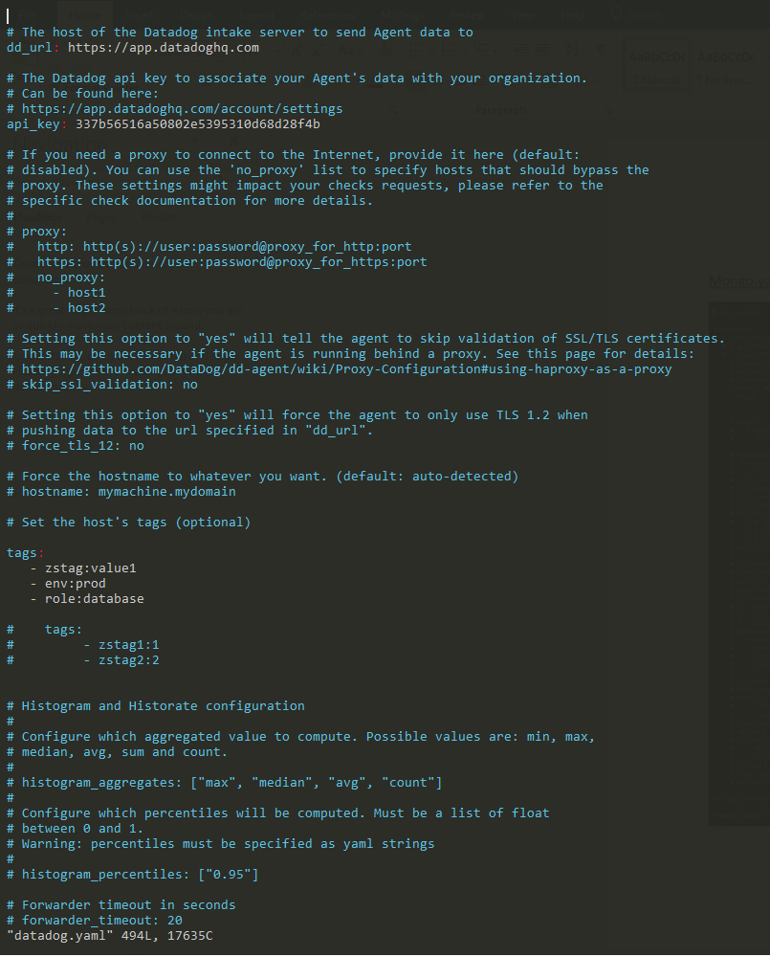

Collecting Metrics - Infrastructure host map

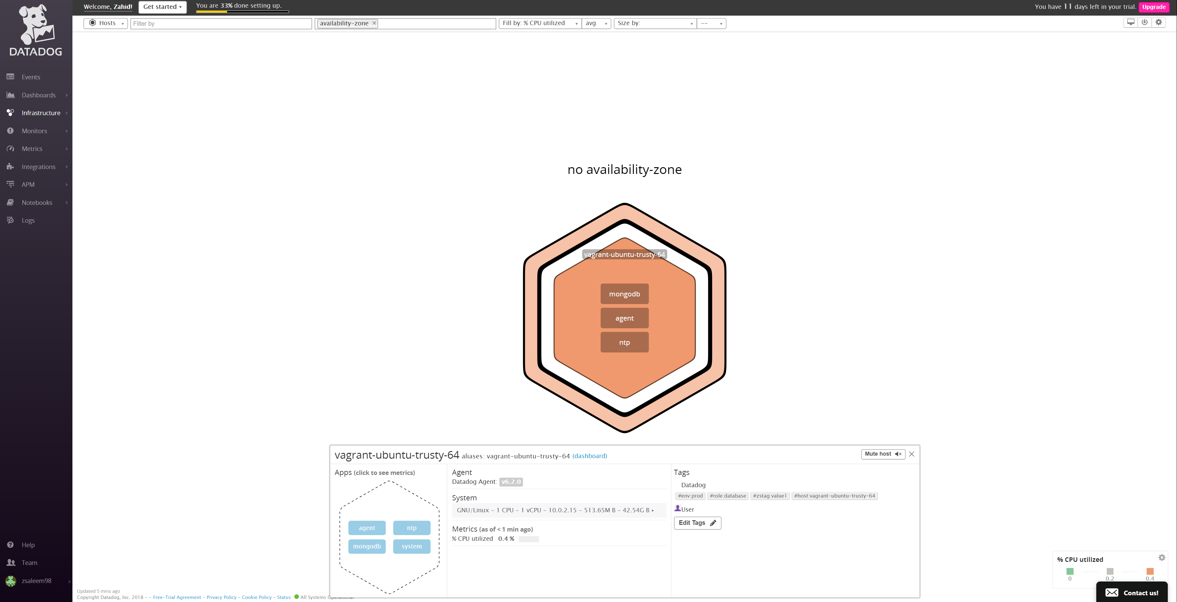

Collecting Metrics - Events

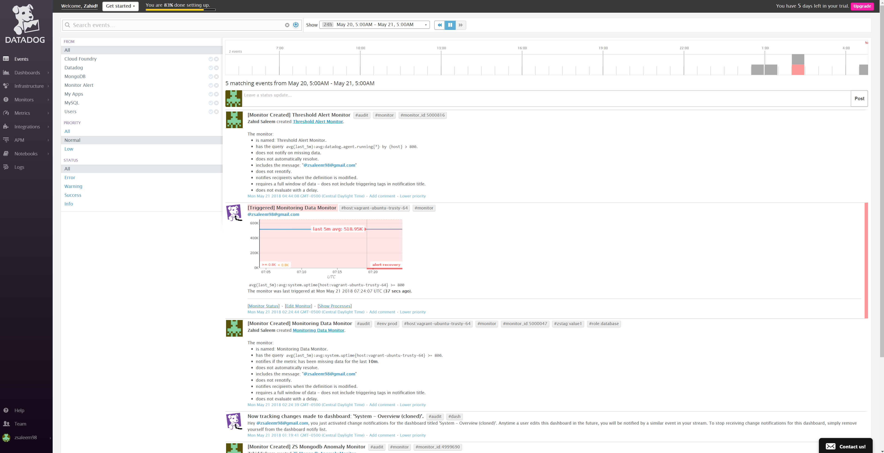

Collecting Metrics - Dashboards

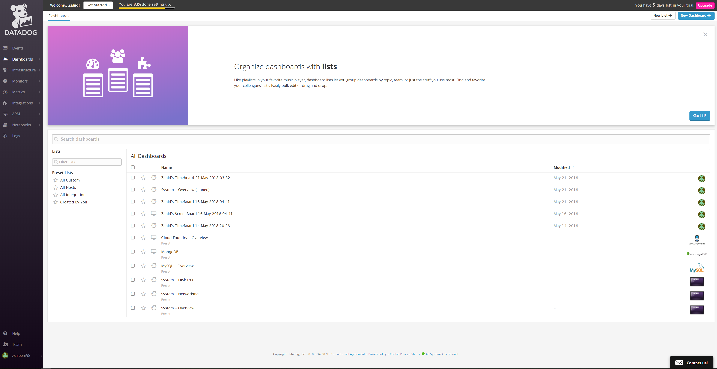

Collecting Metrics – Infrastructure

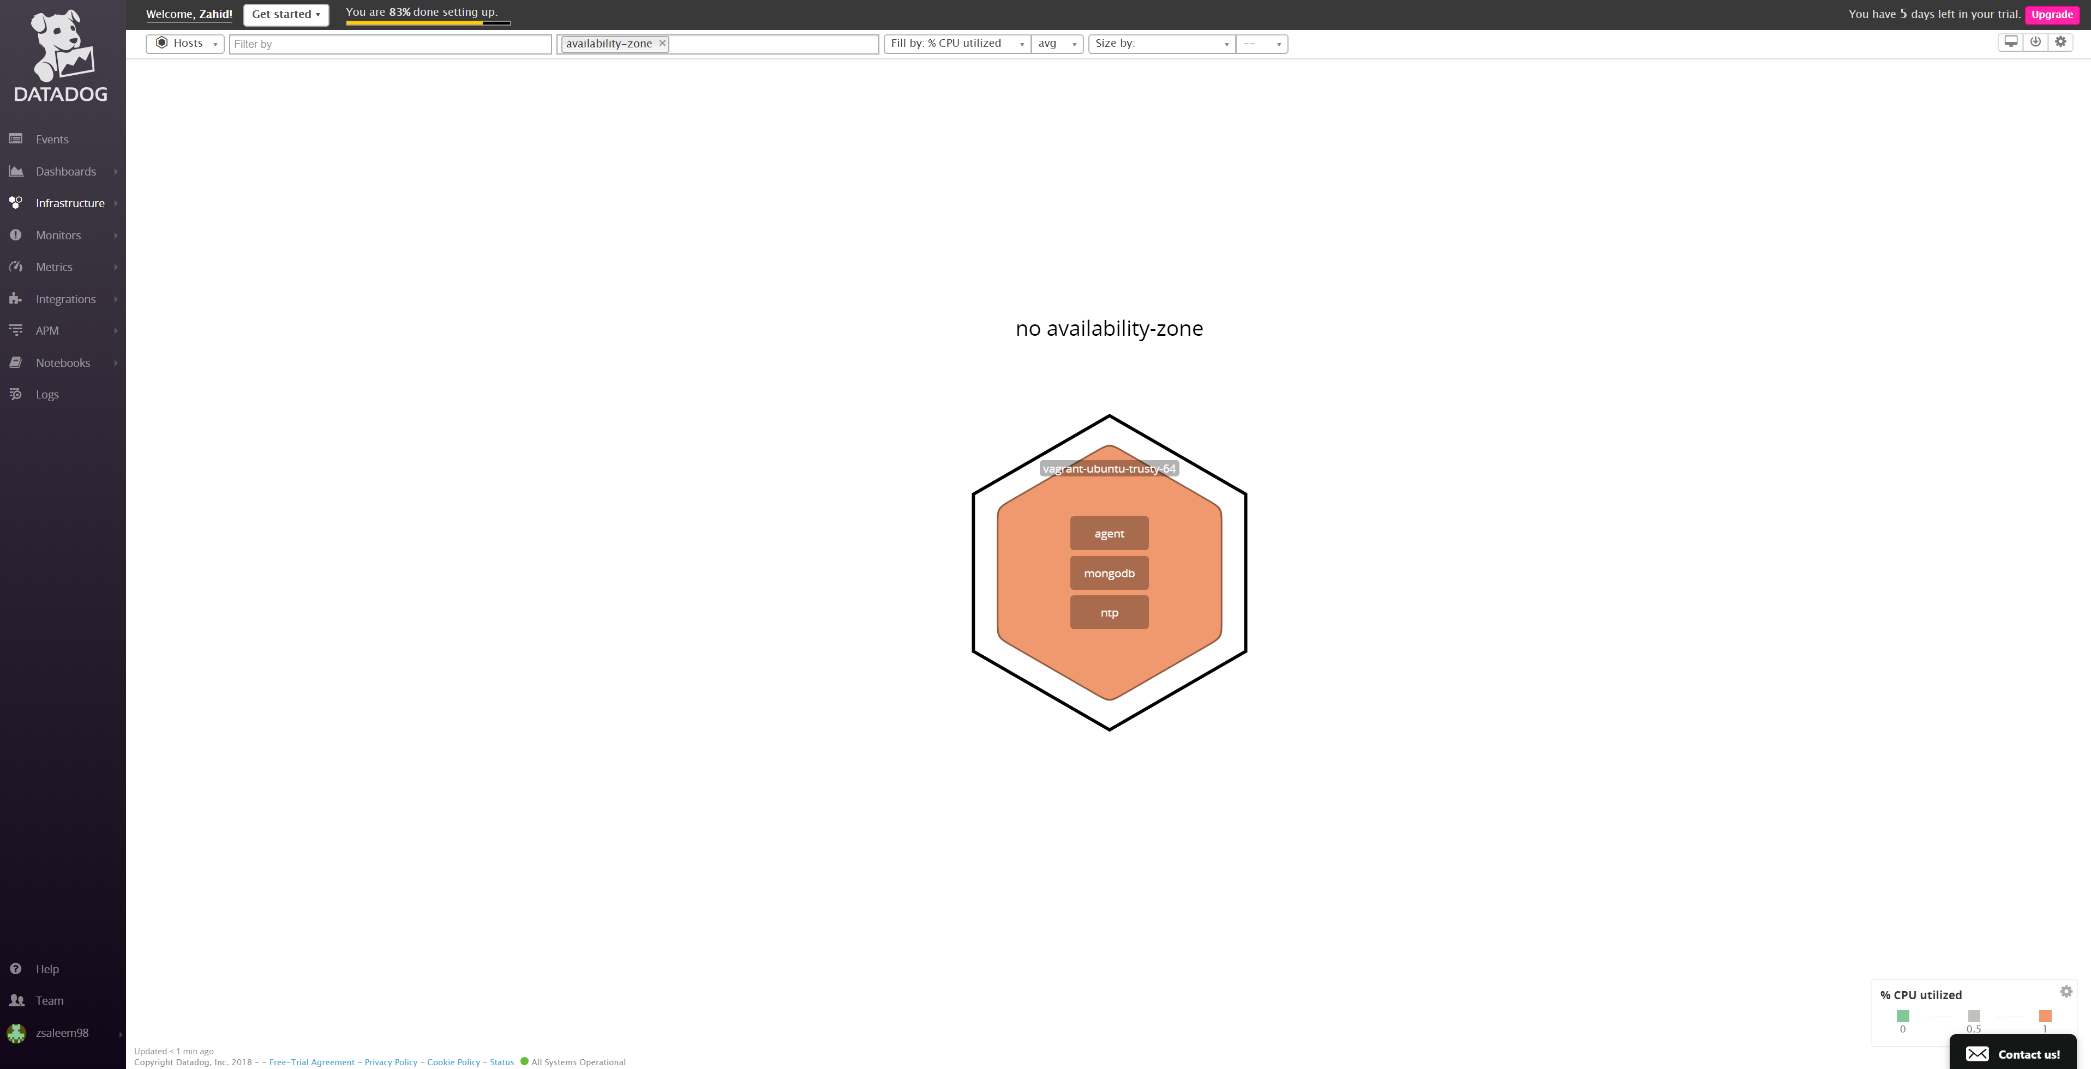

Collecting Metrics – Infrastructure (host and its tags)

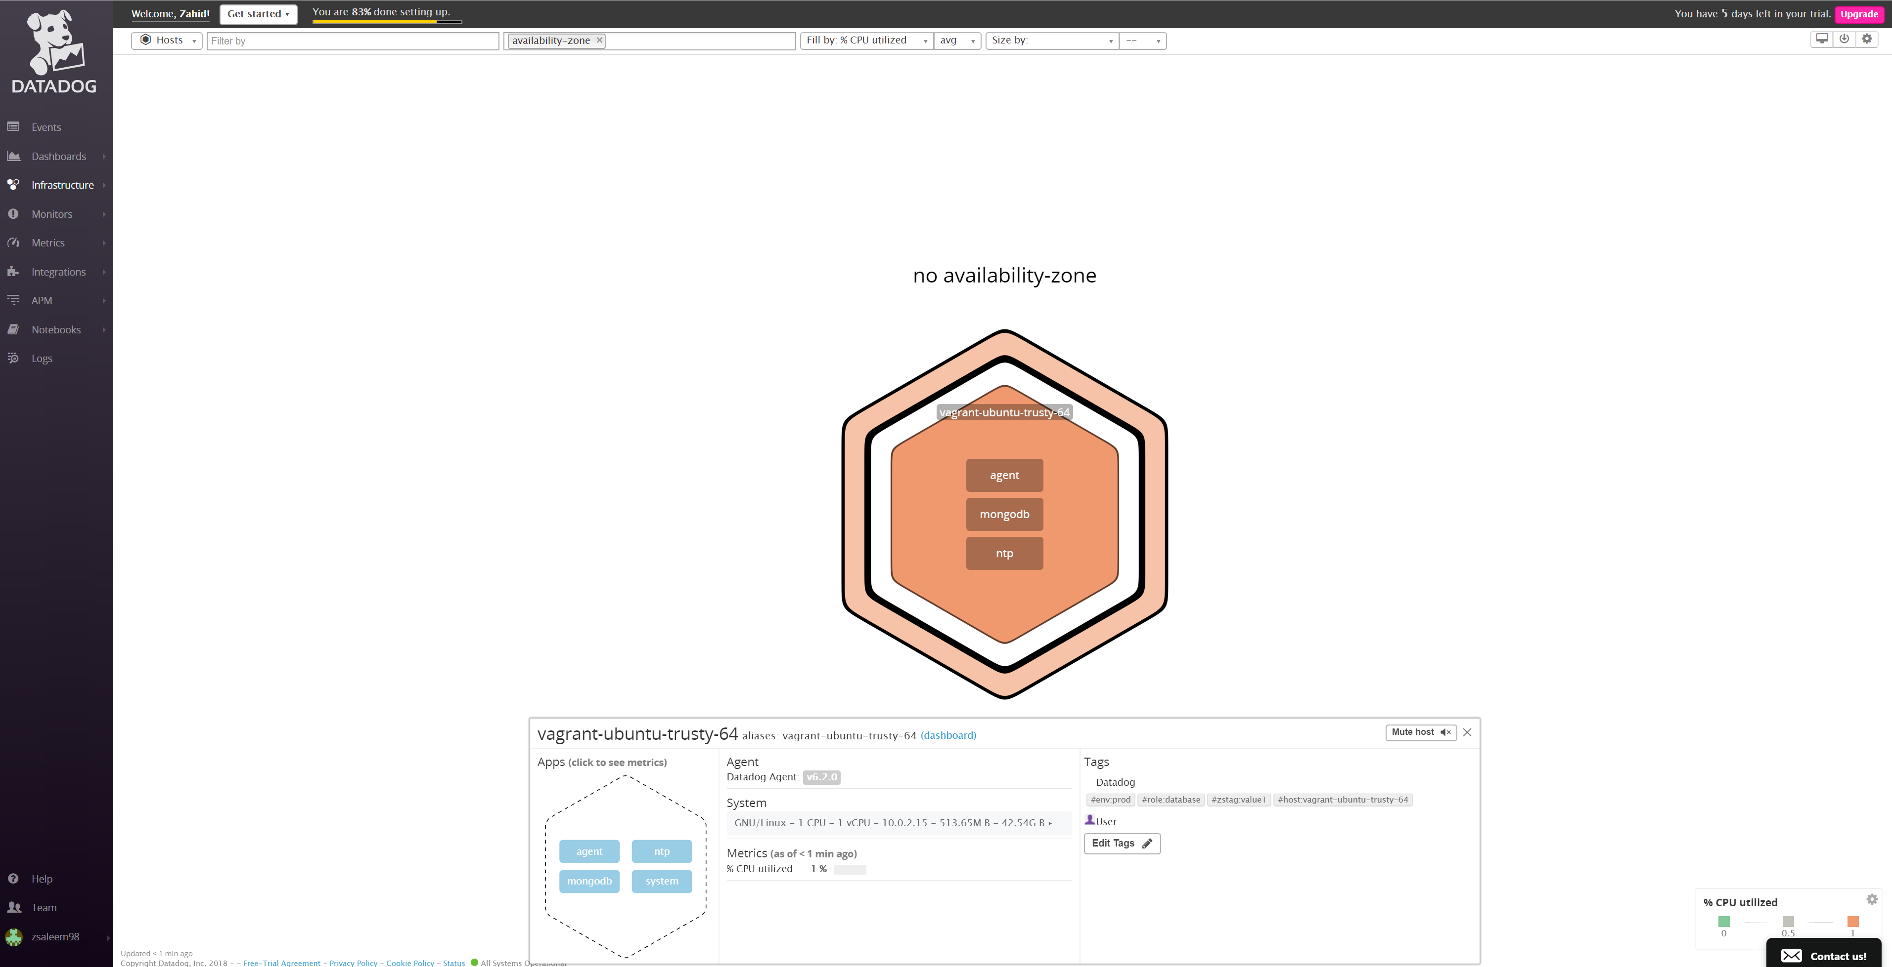

Collecting Metrics – Infrastructure (hosts)

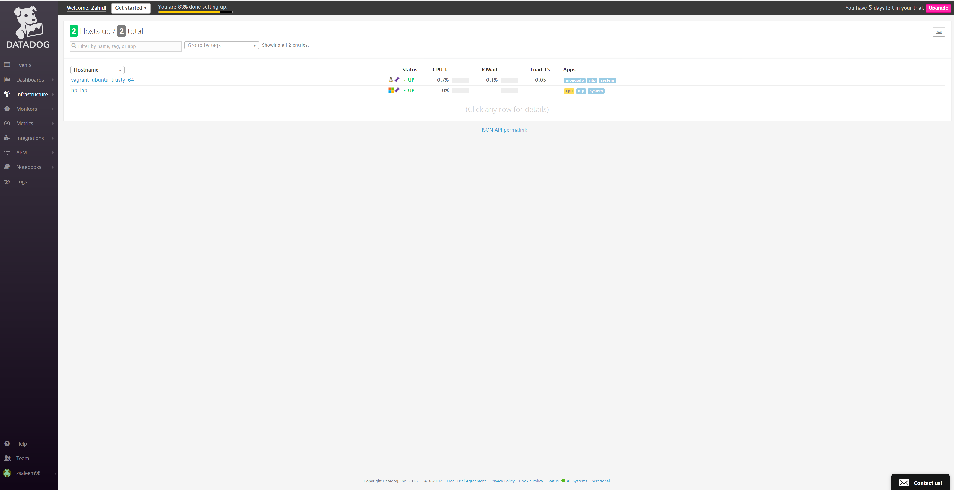

Collecting Metrics - Monitors

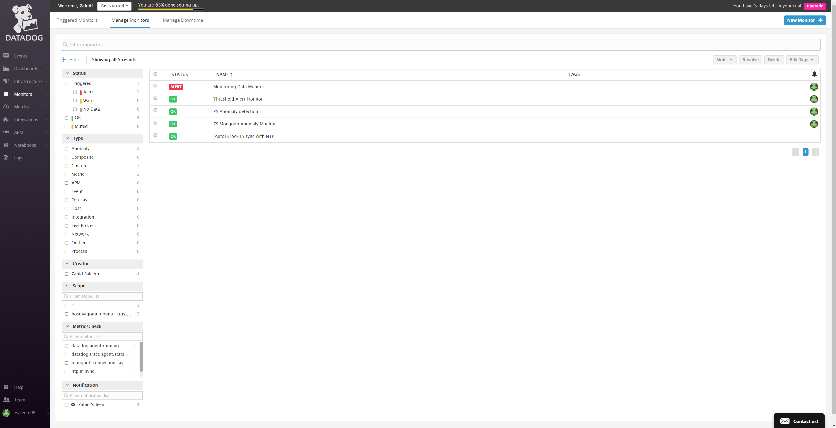

Collecting Metrics – Monitors (triggered)

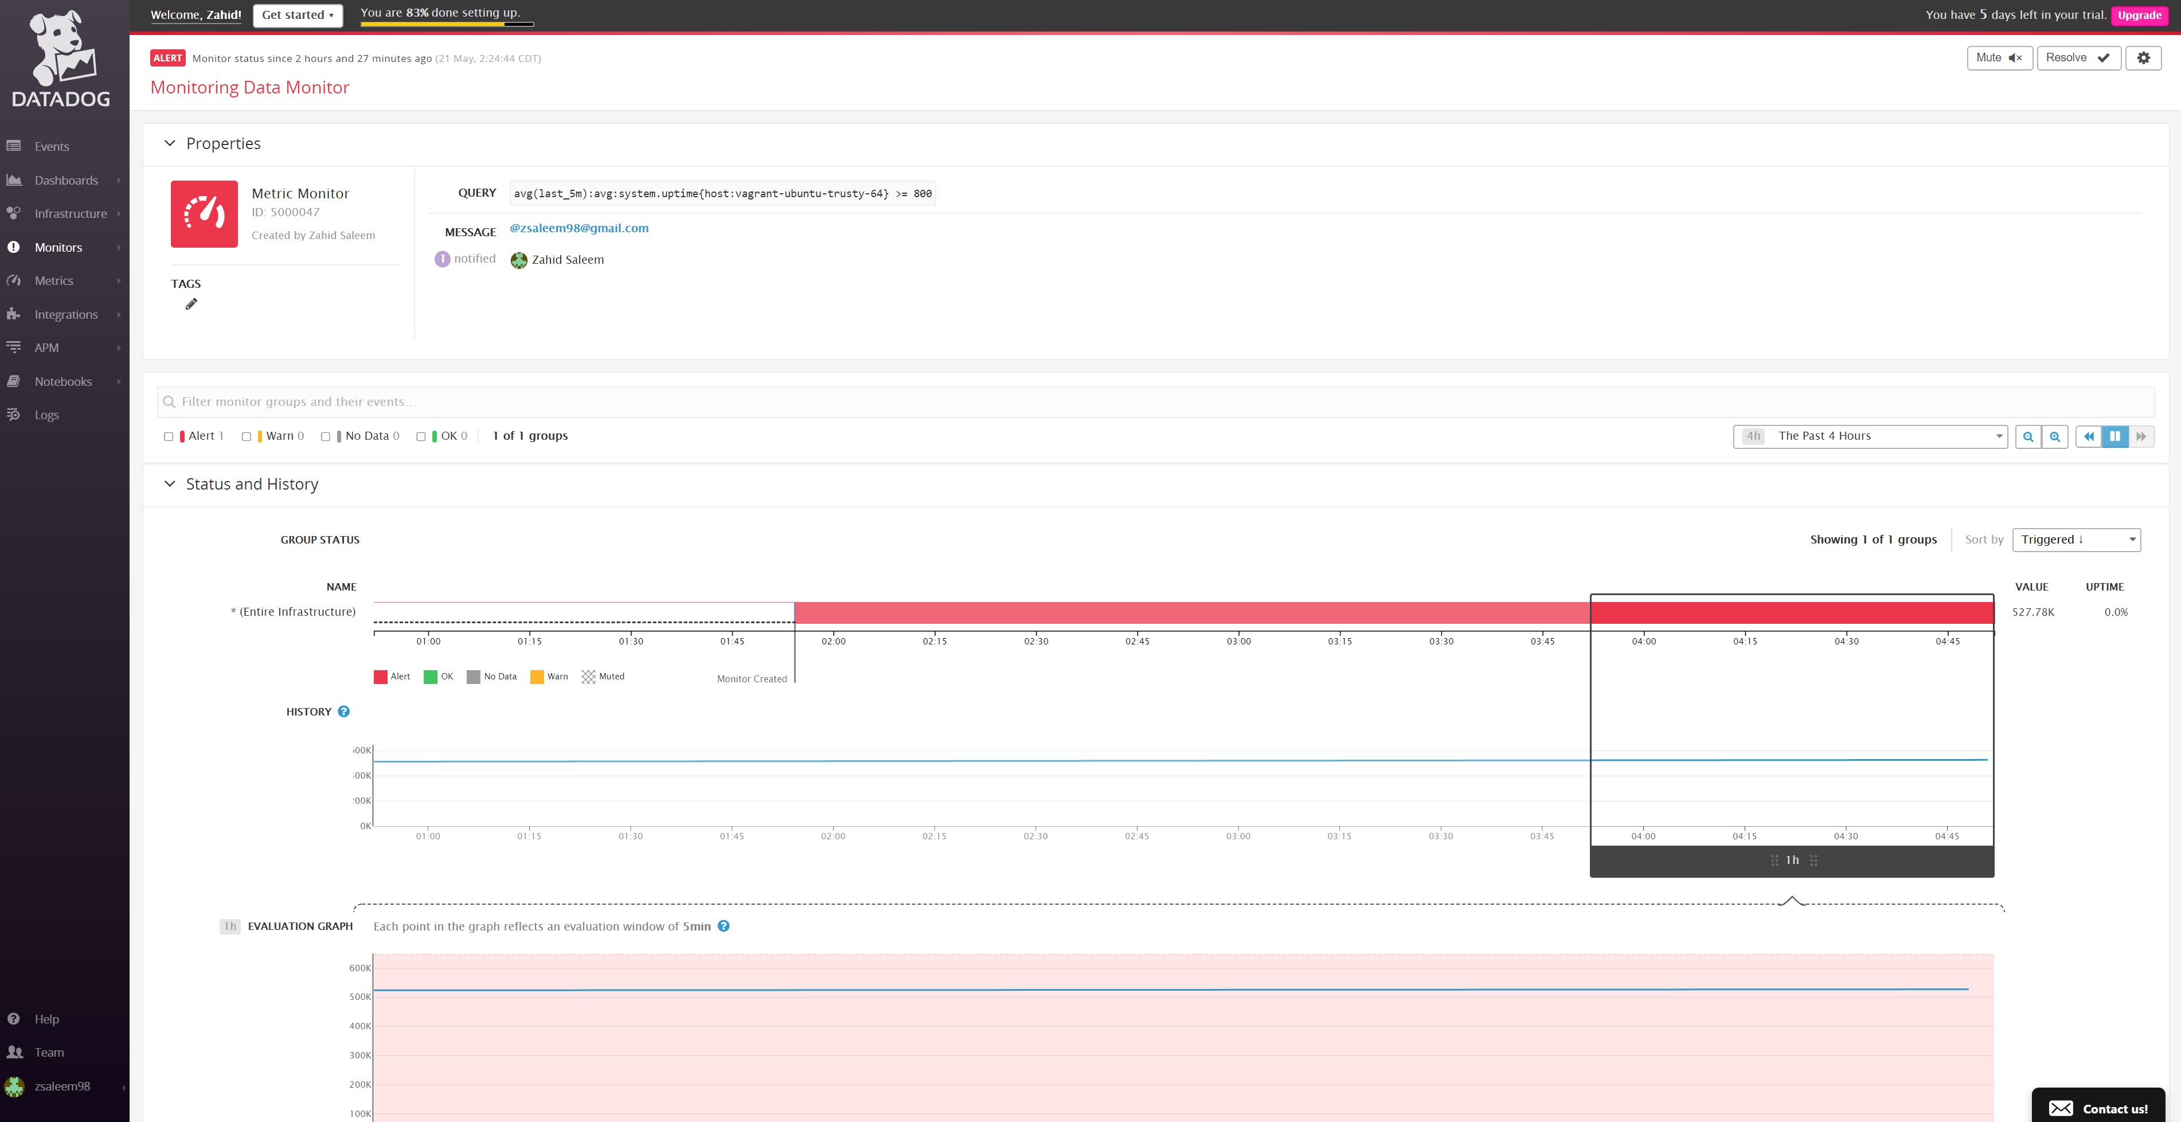

Collecting Metrics – Monitors (Threshold Alert Monitor)

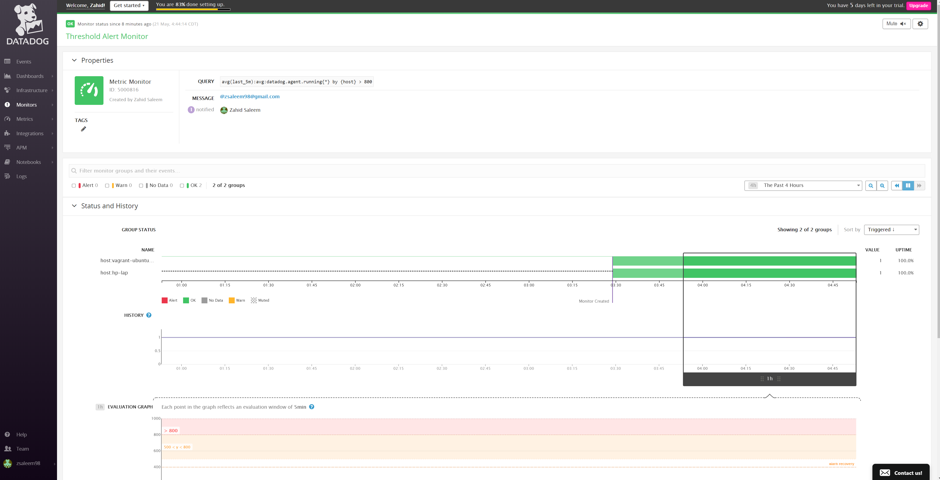

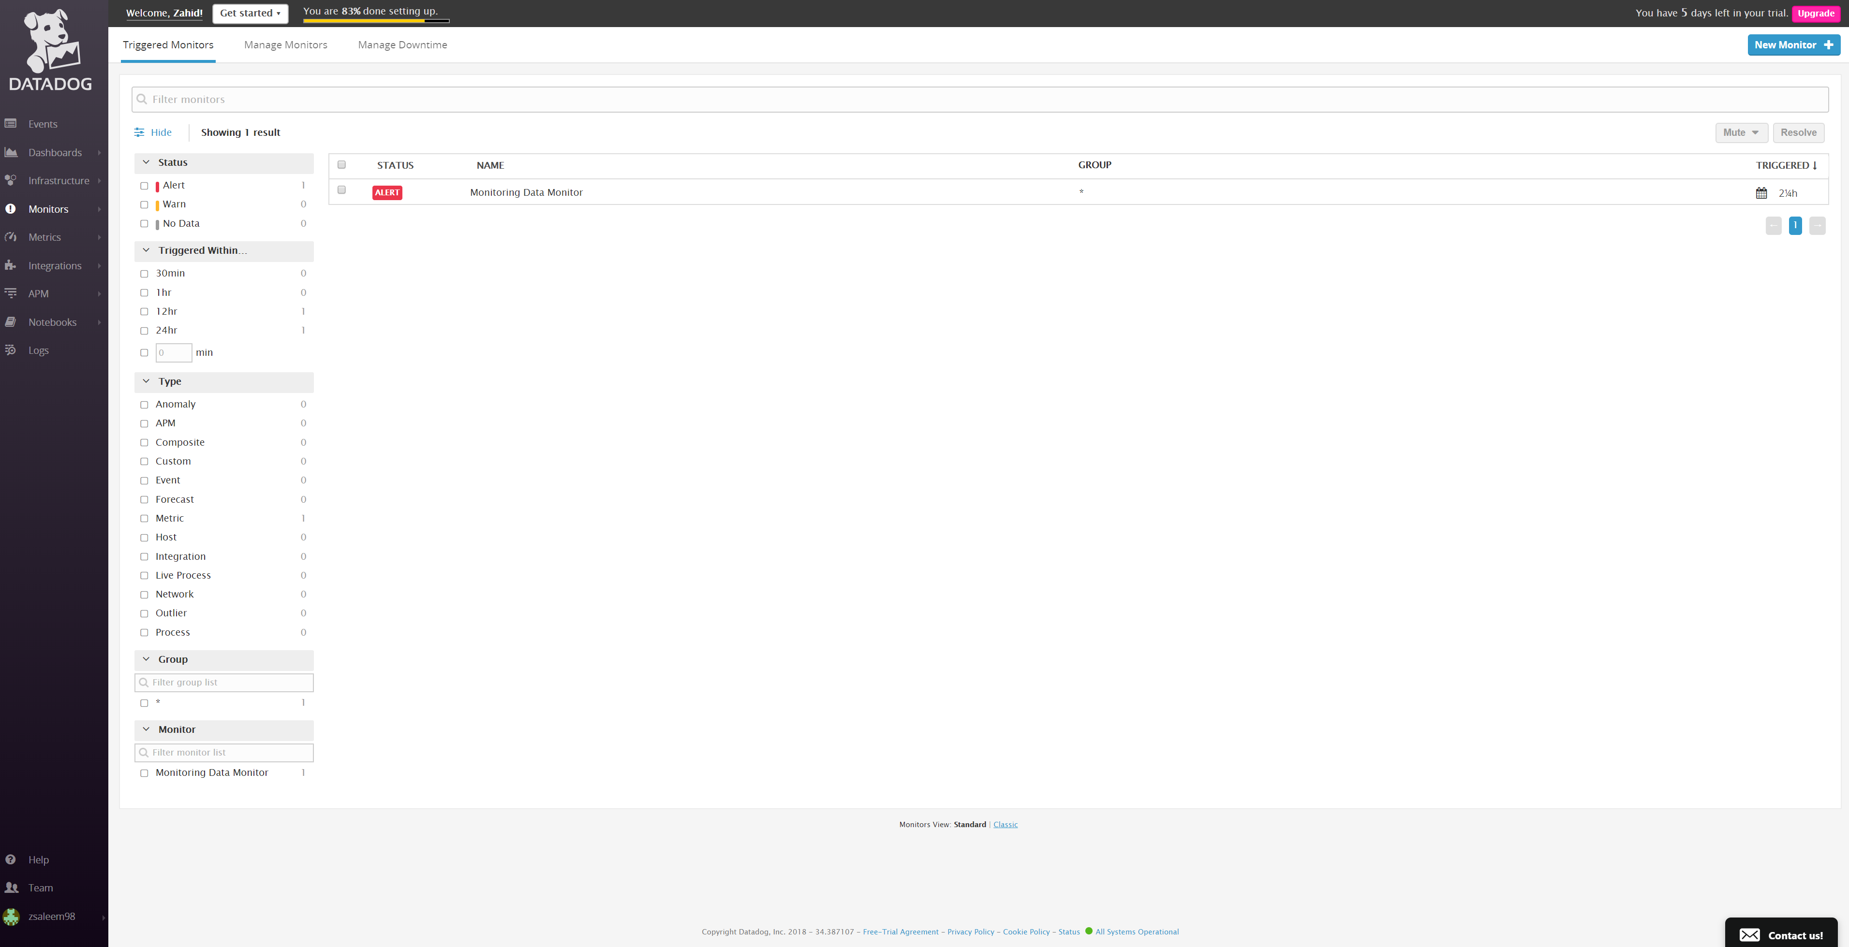

Collecting Metrics – All Checks

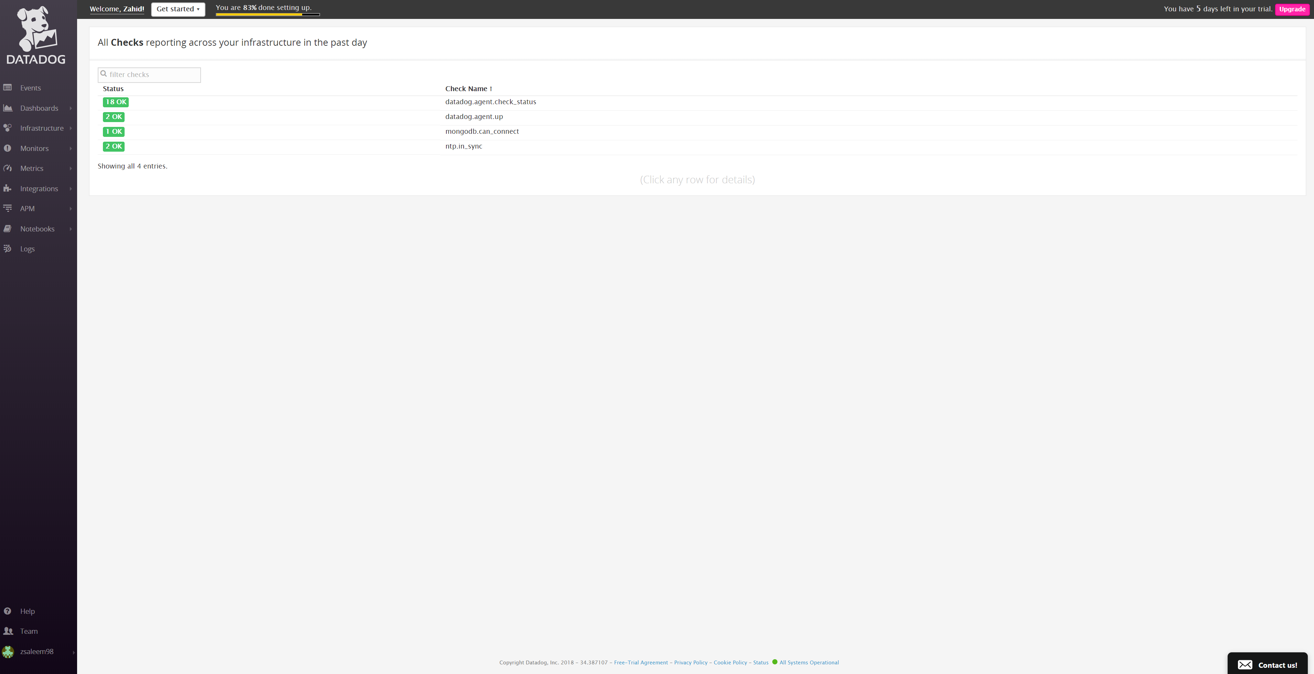

Collecting Metrics – Integrations installed

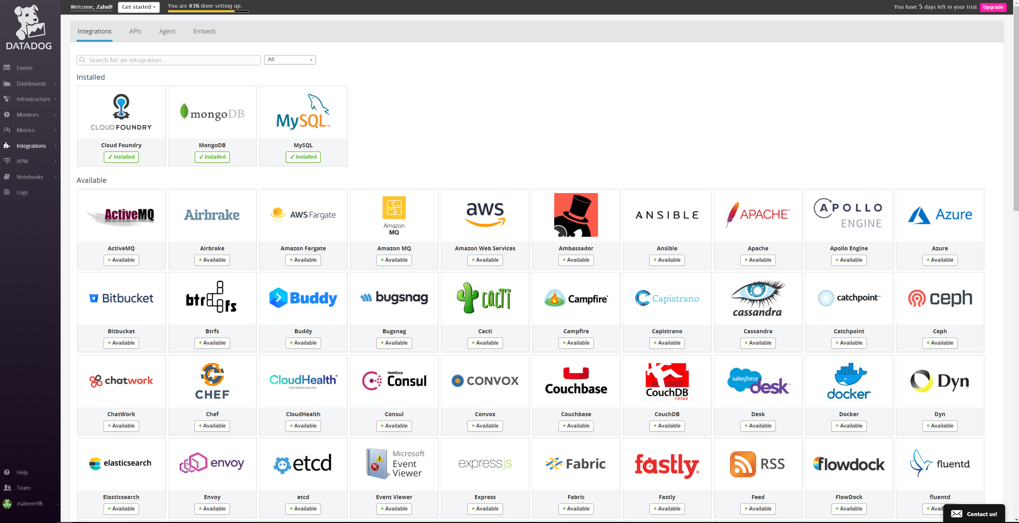

Collecting Metrics – API key created

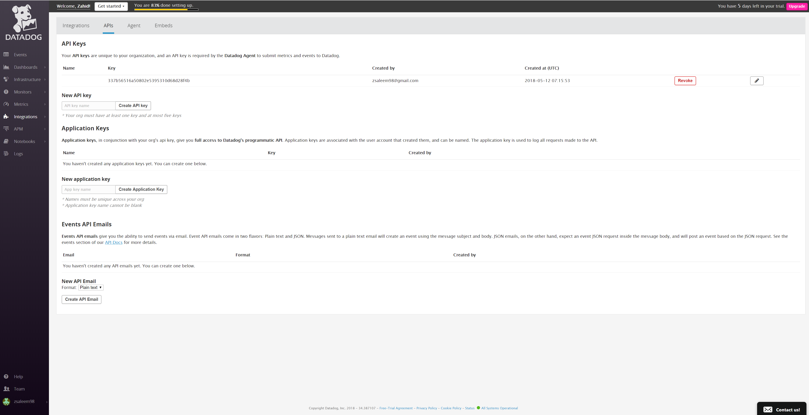

Collecting Metrics - Notebooks

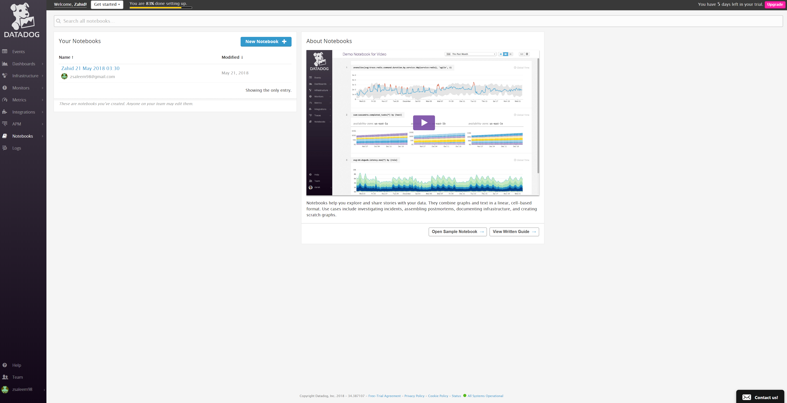

Collecting Metrics – Notebook created

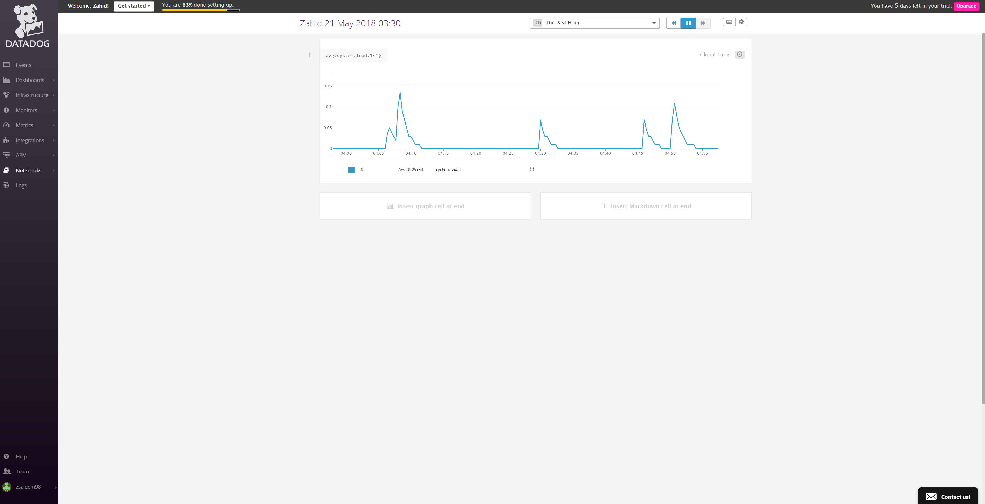

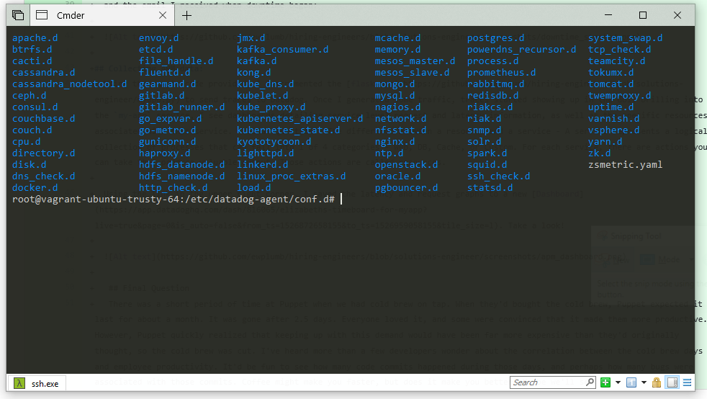

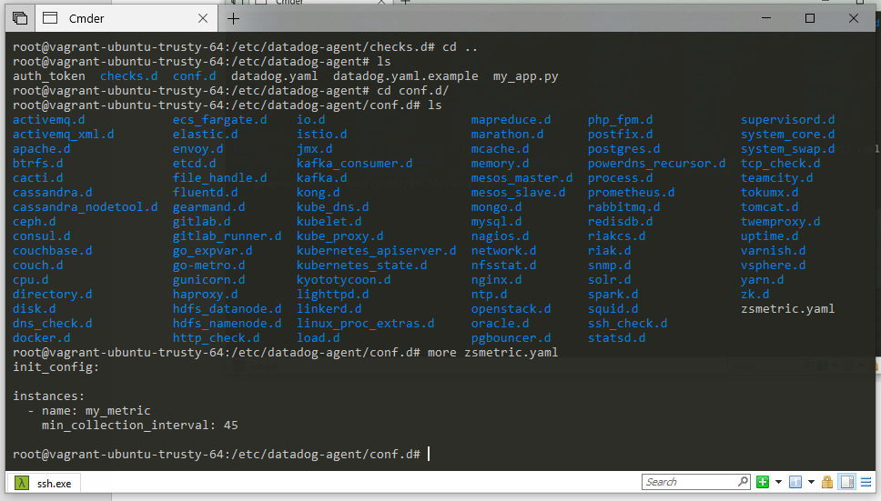

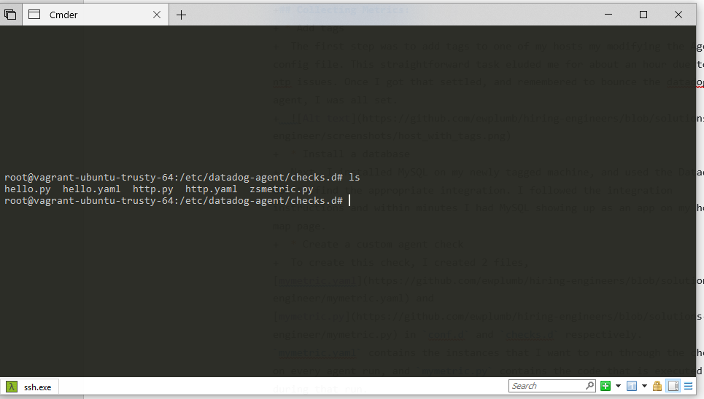

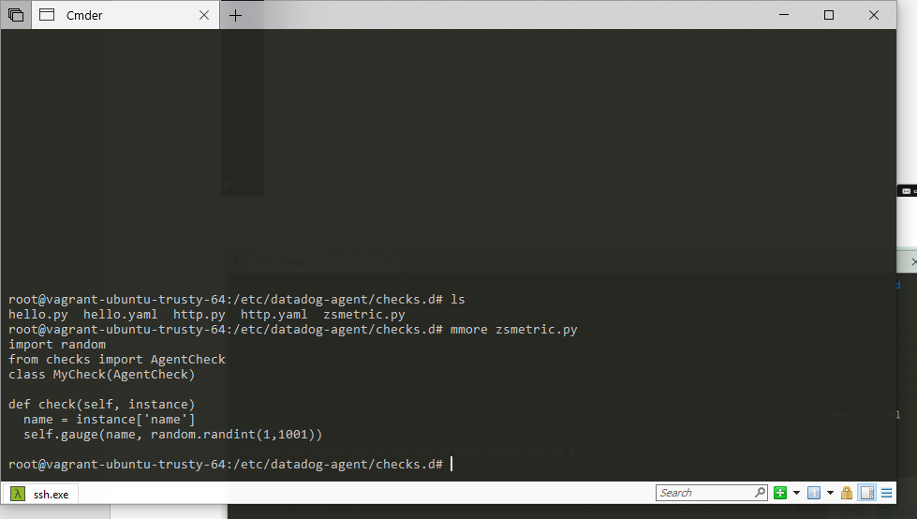

MongoDB

Mongo.yaml

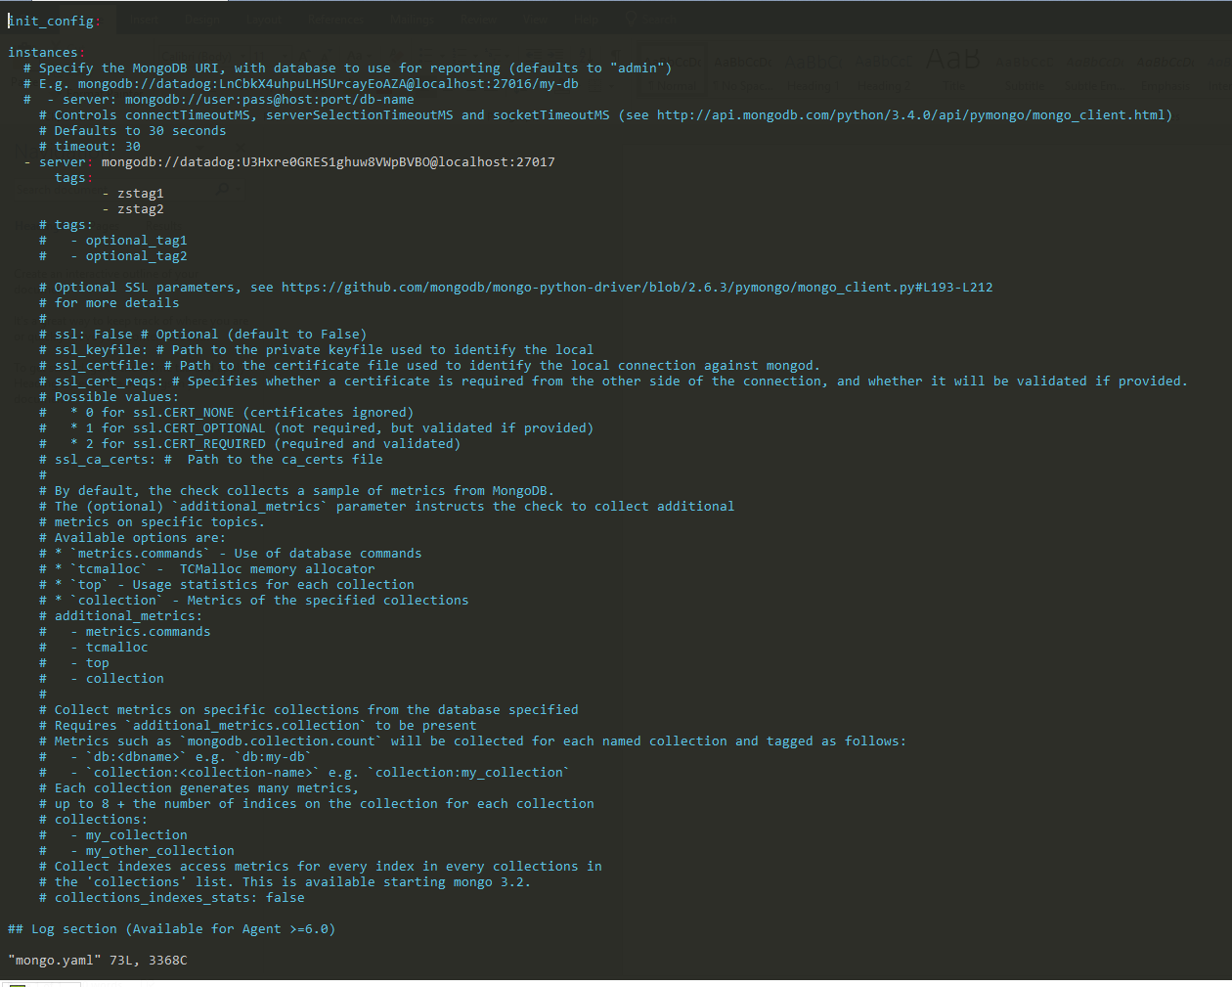

MongoDB

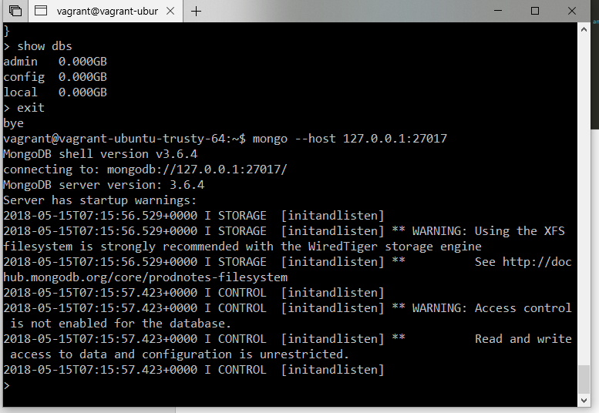

PCF dev installed on Vagrant VM

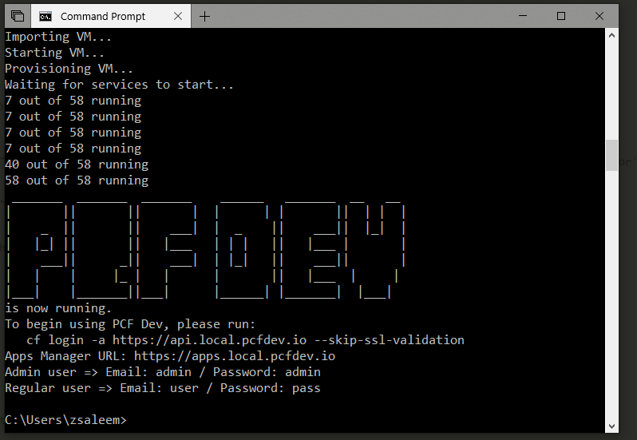

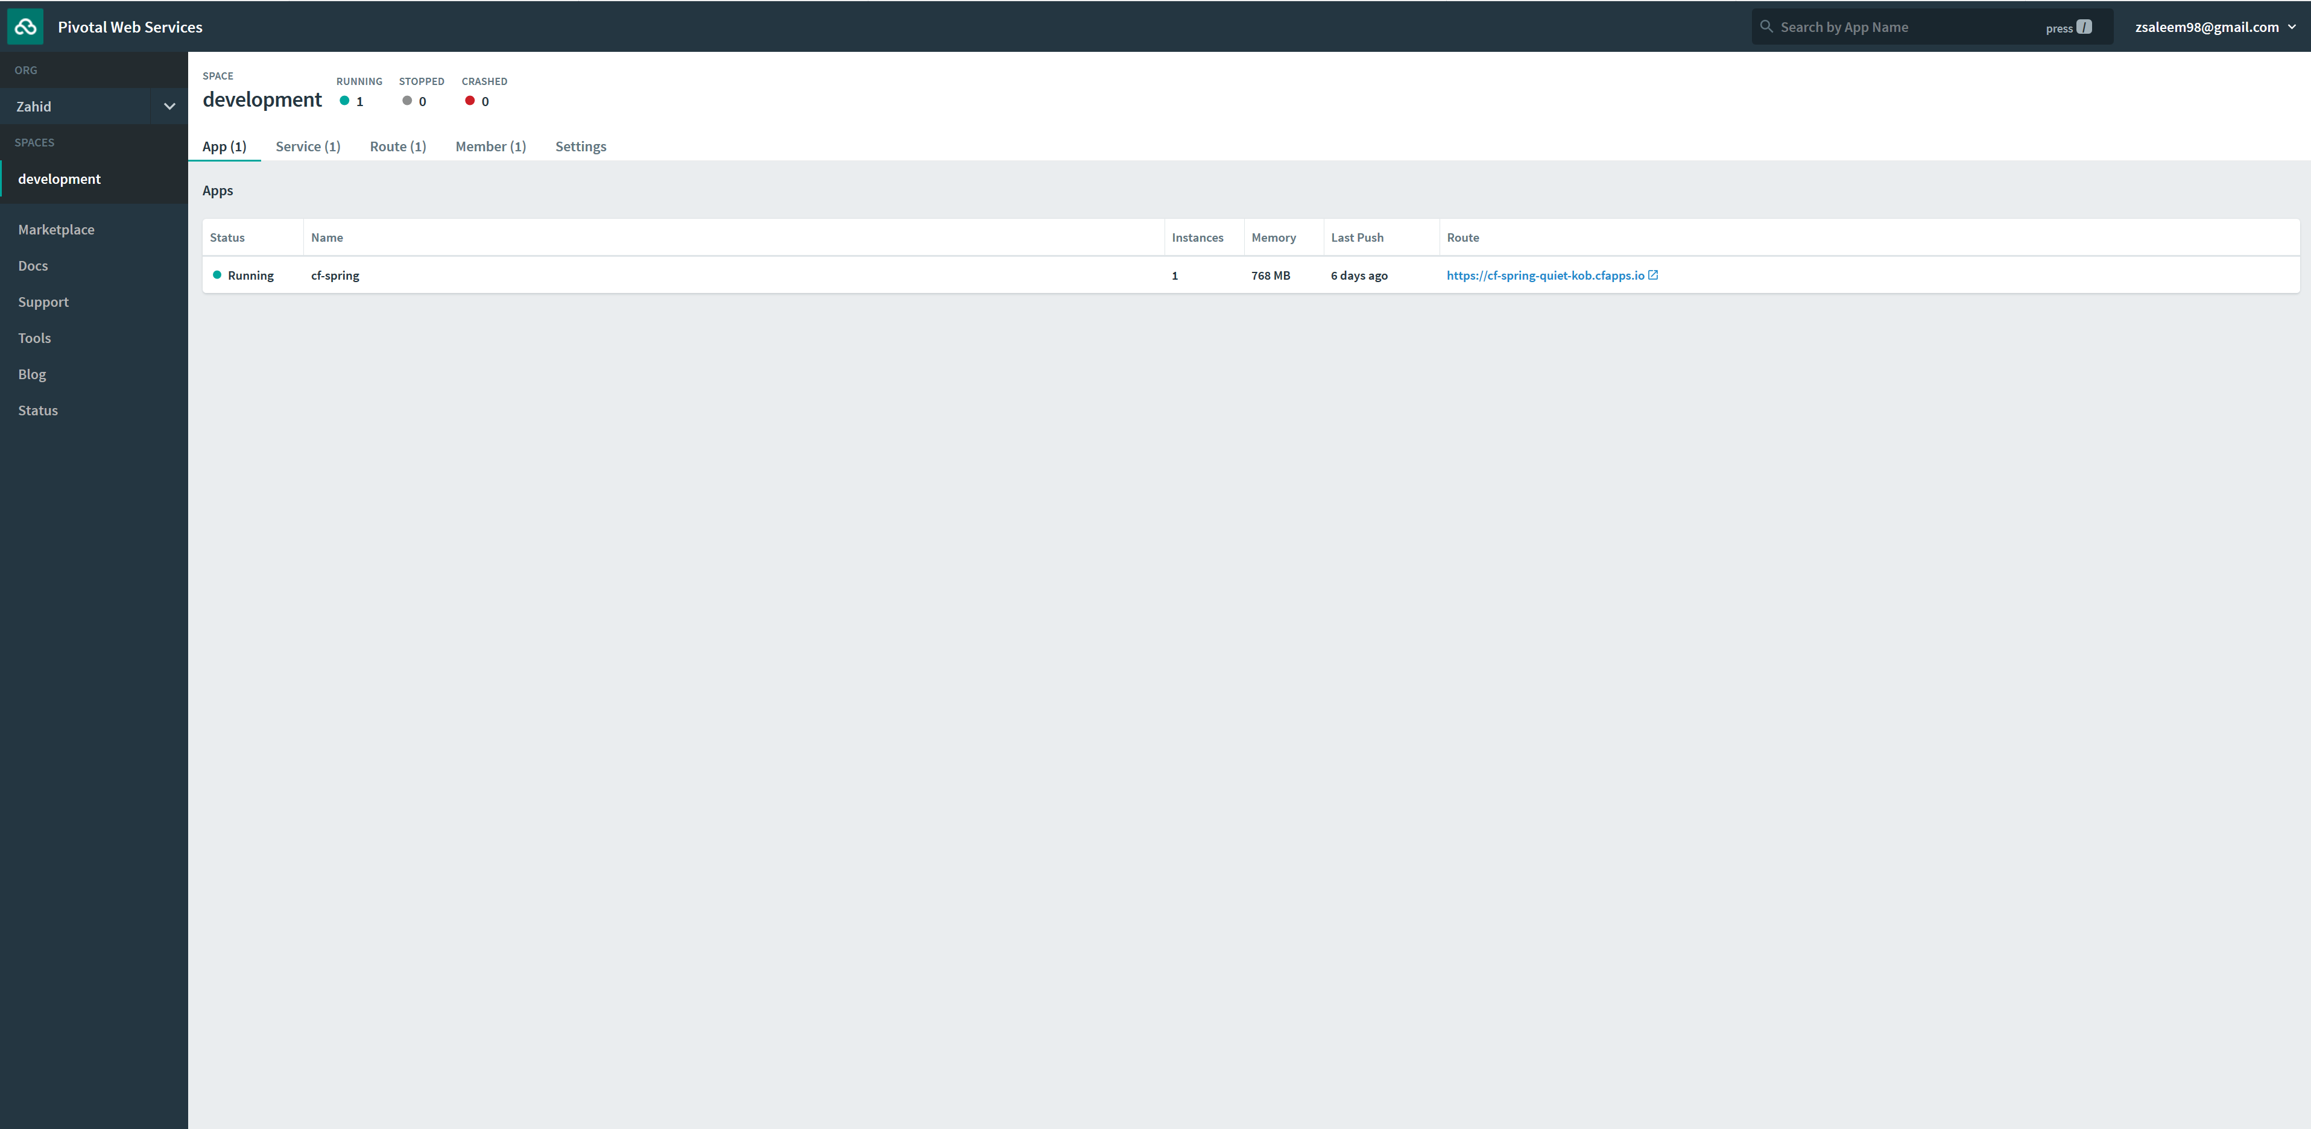

PCF Meta-buildpack installed

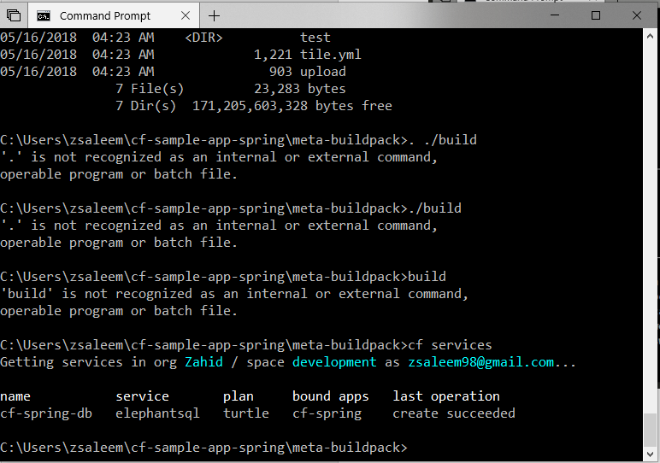

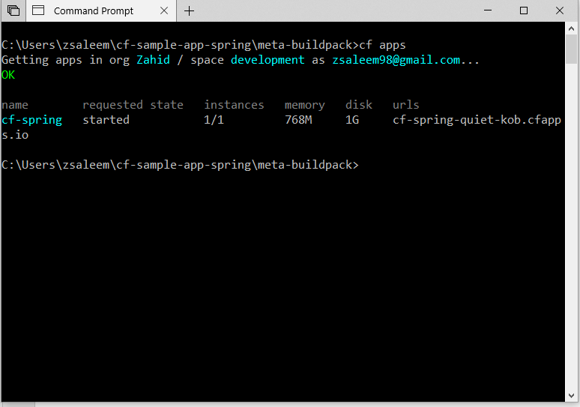

Visualizing Data – Dashboard host vagrant

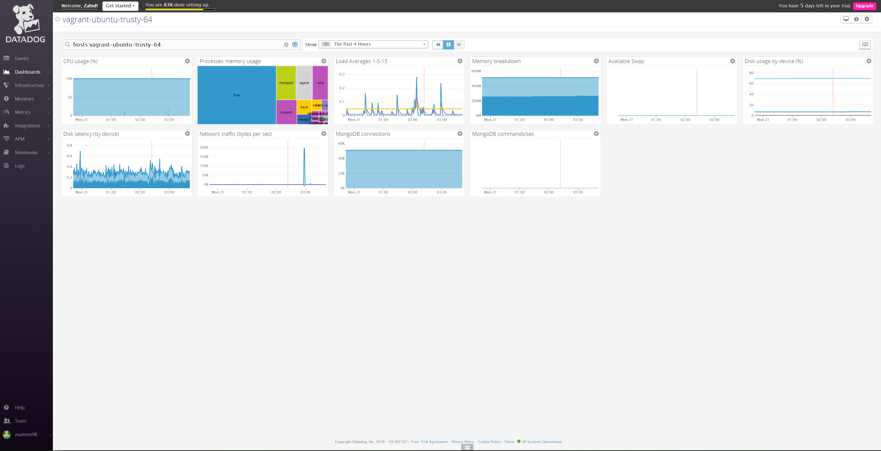

Monitoring Data – Metrics Explorer

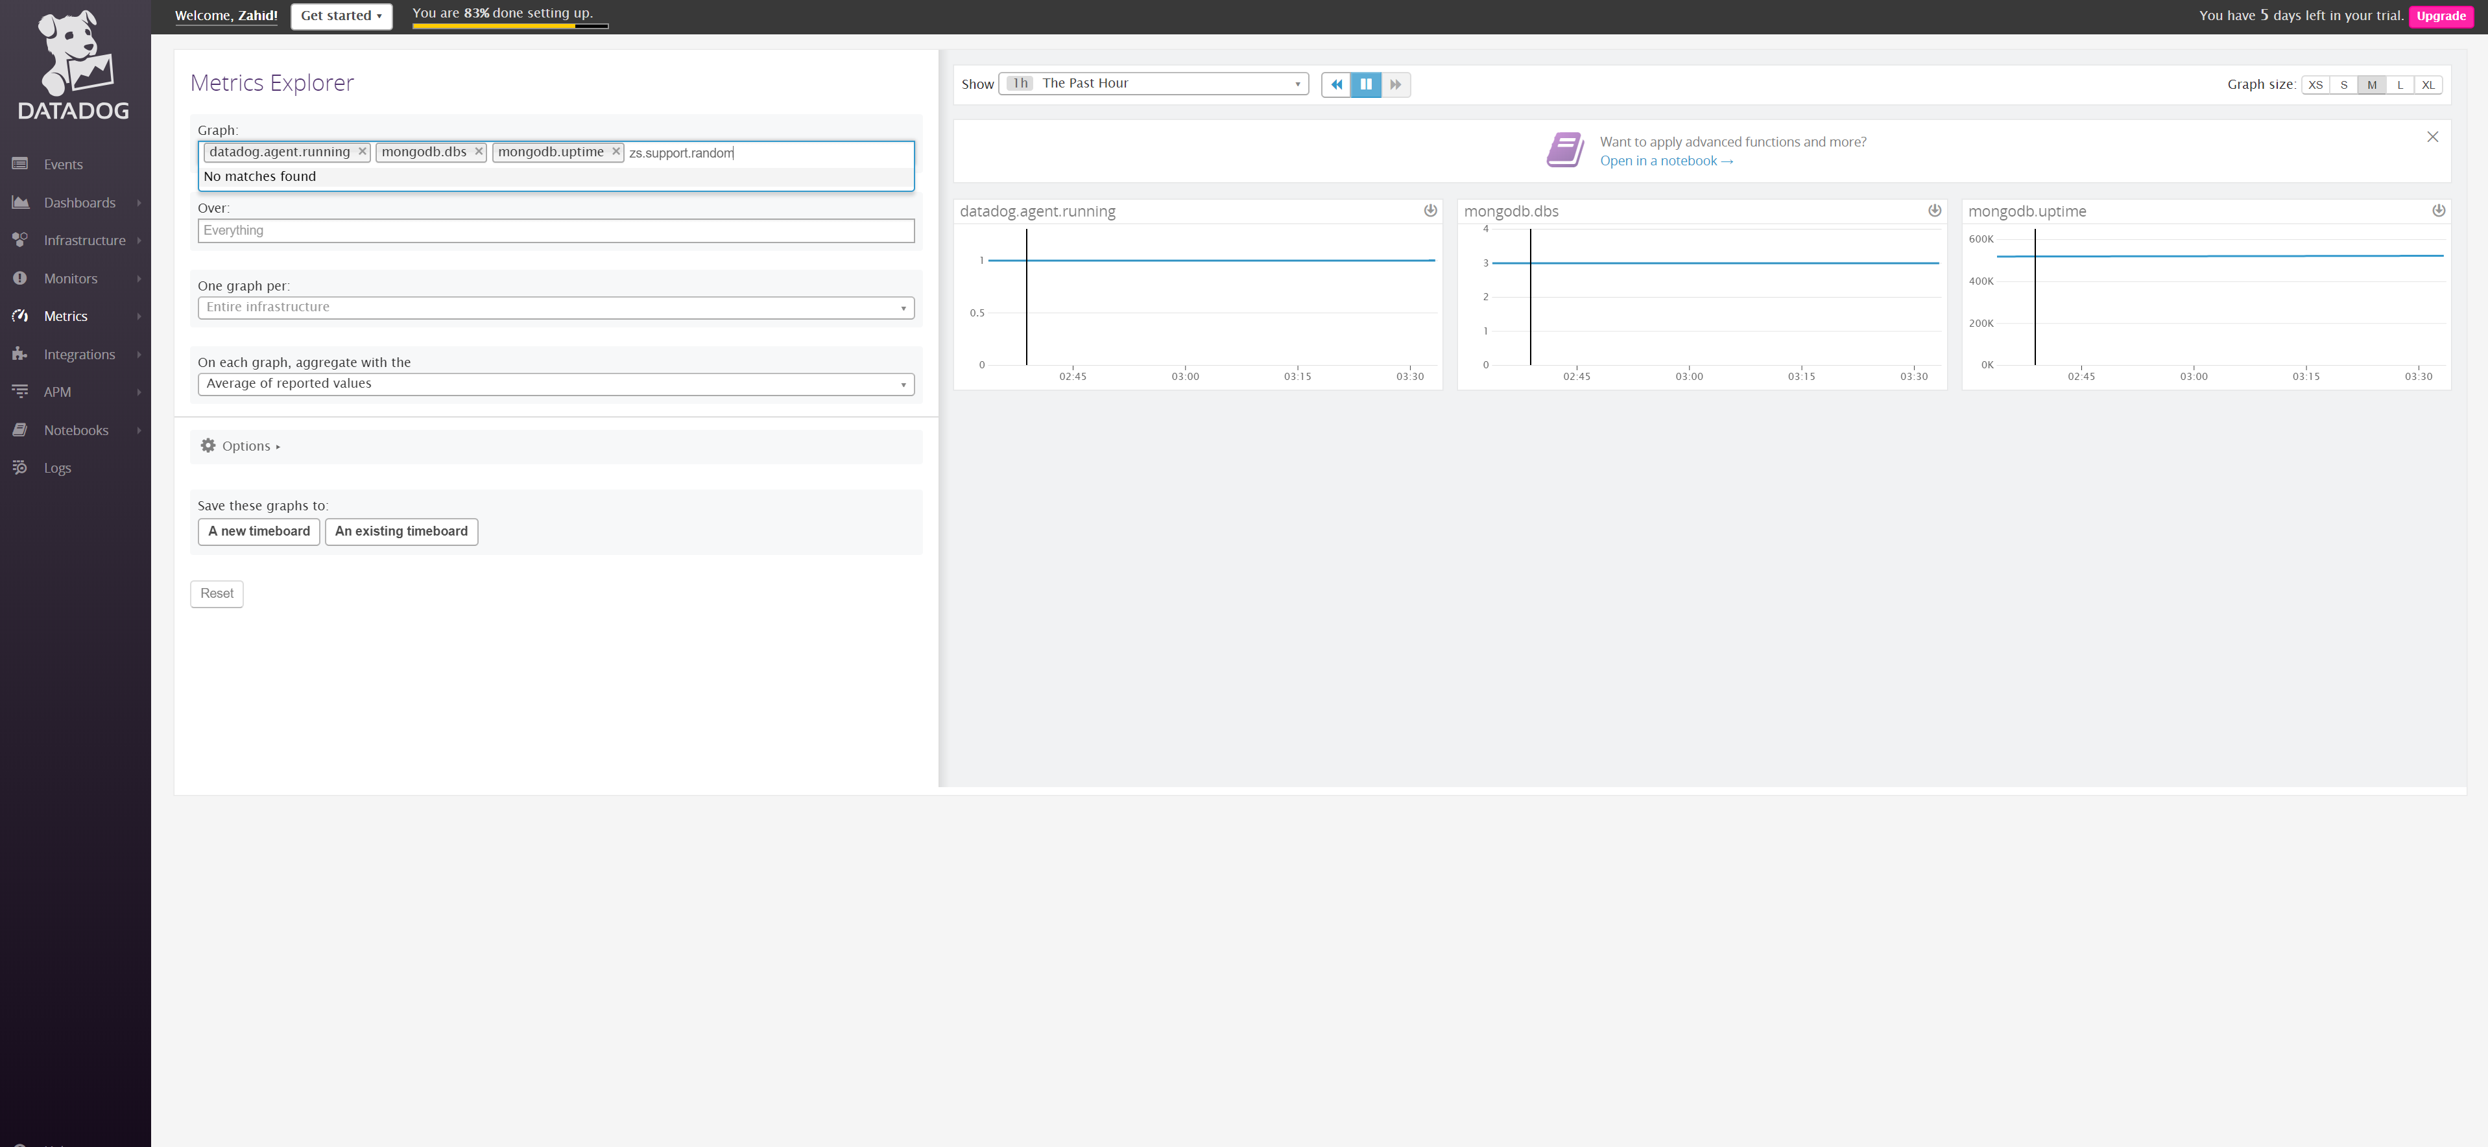

Monitoring Data – Metrics Explorer

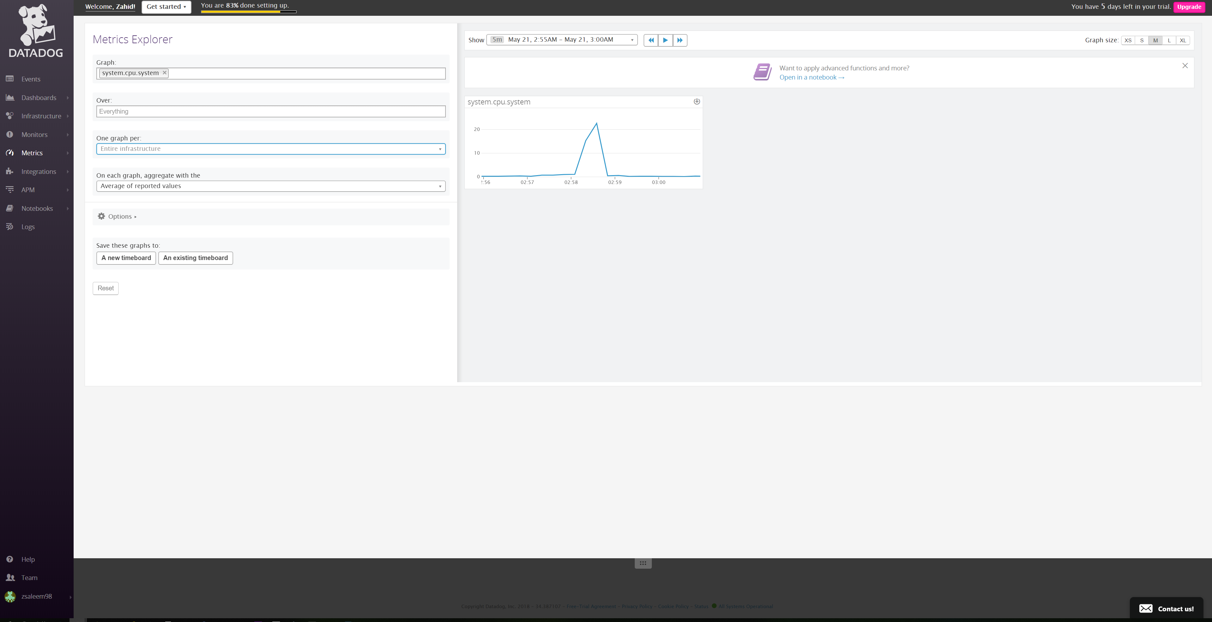

Monitoring Data - MySQL

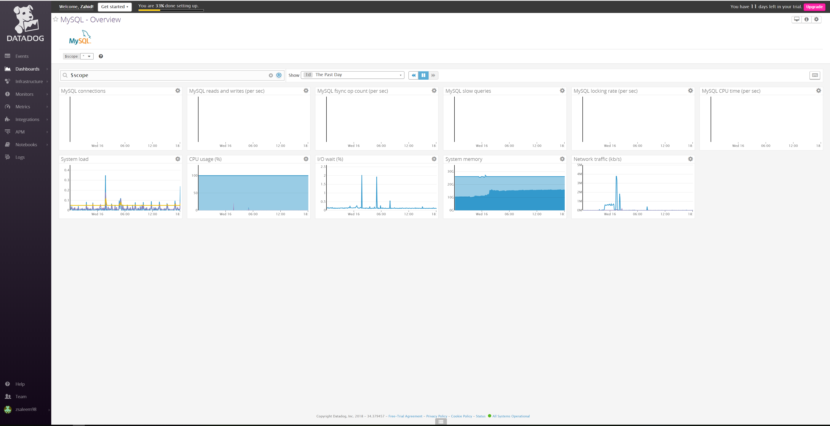

Monitoring Data - MongoDB

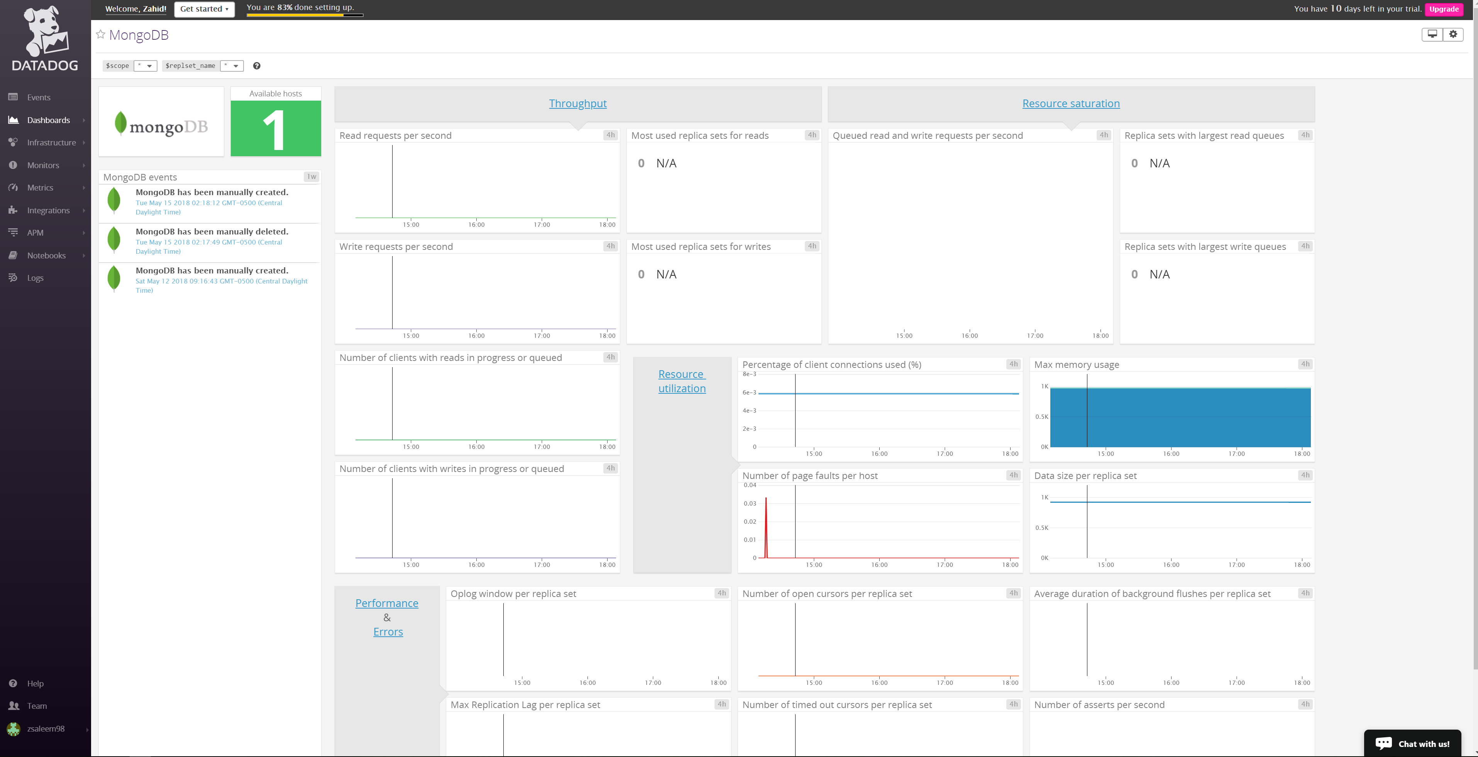

Monitoring Data - Integrations

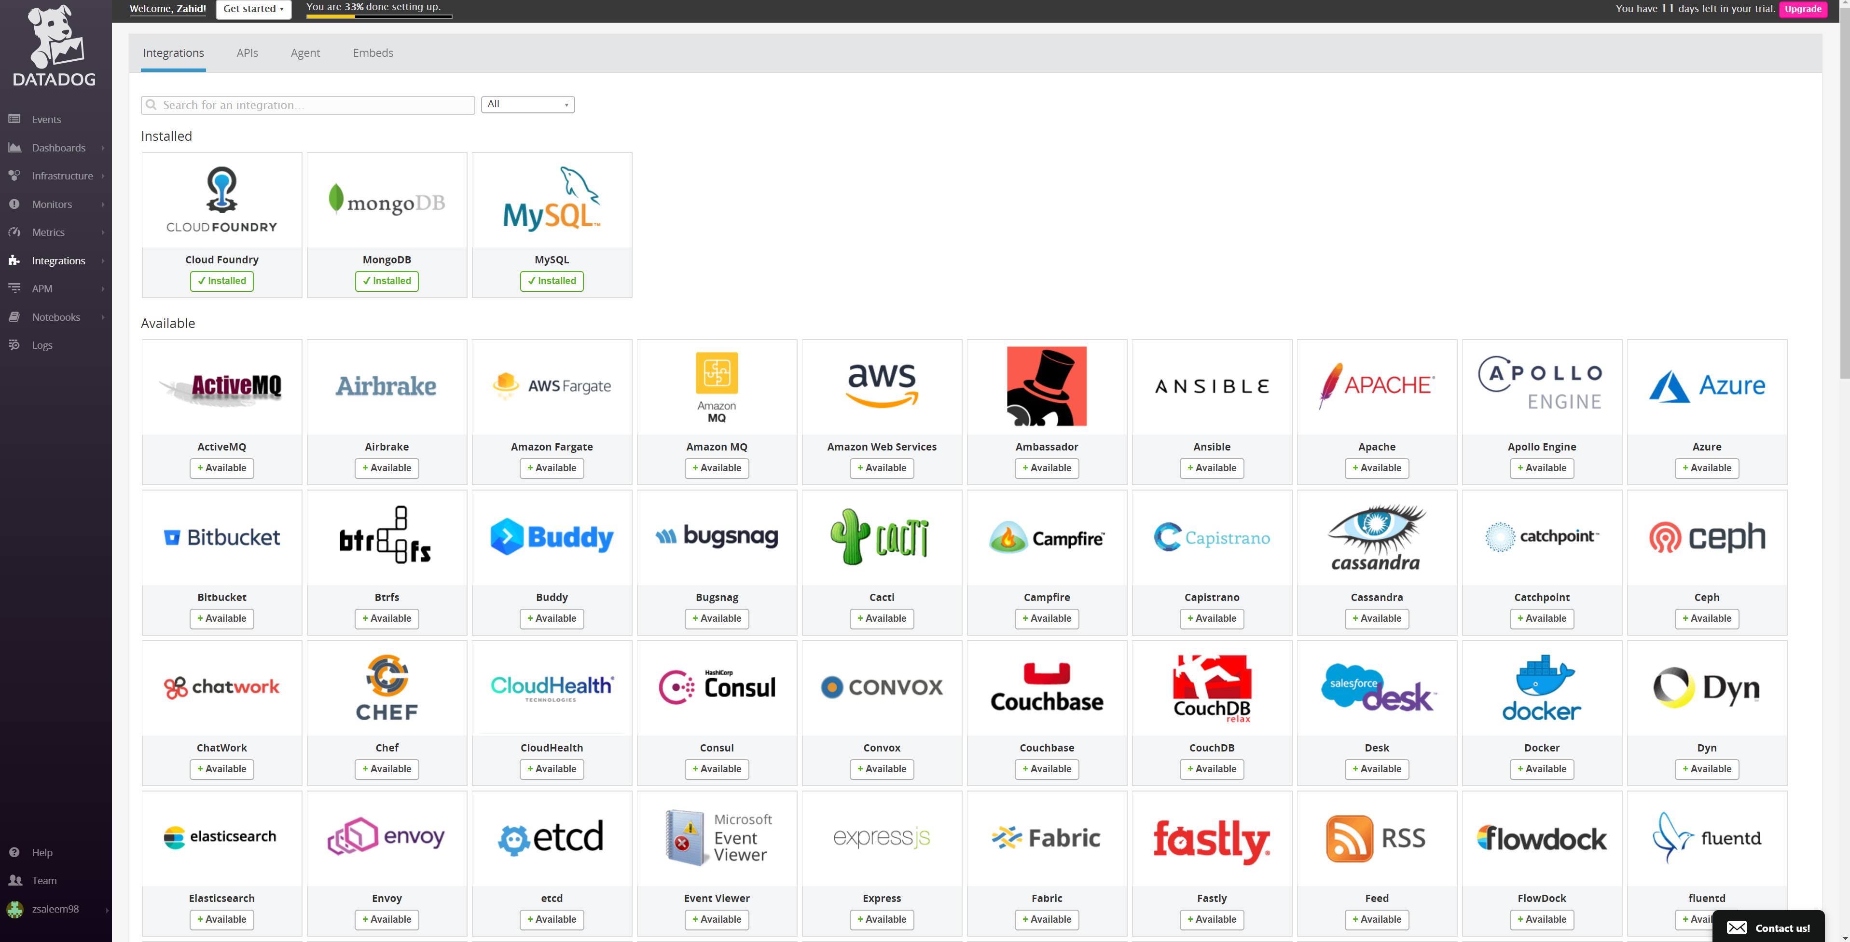

Monitoring Data – Infrastructure hosts

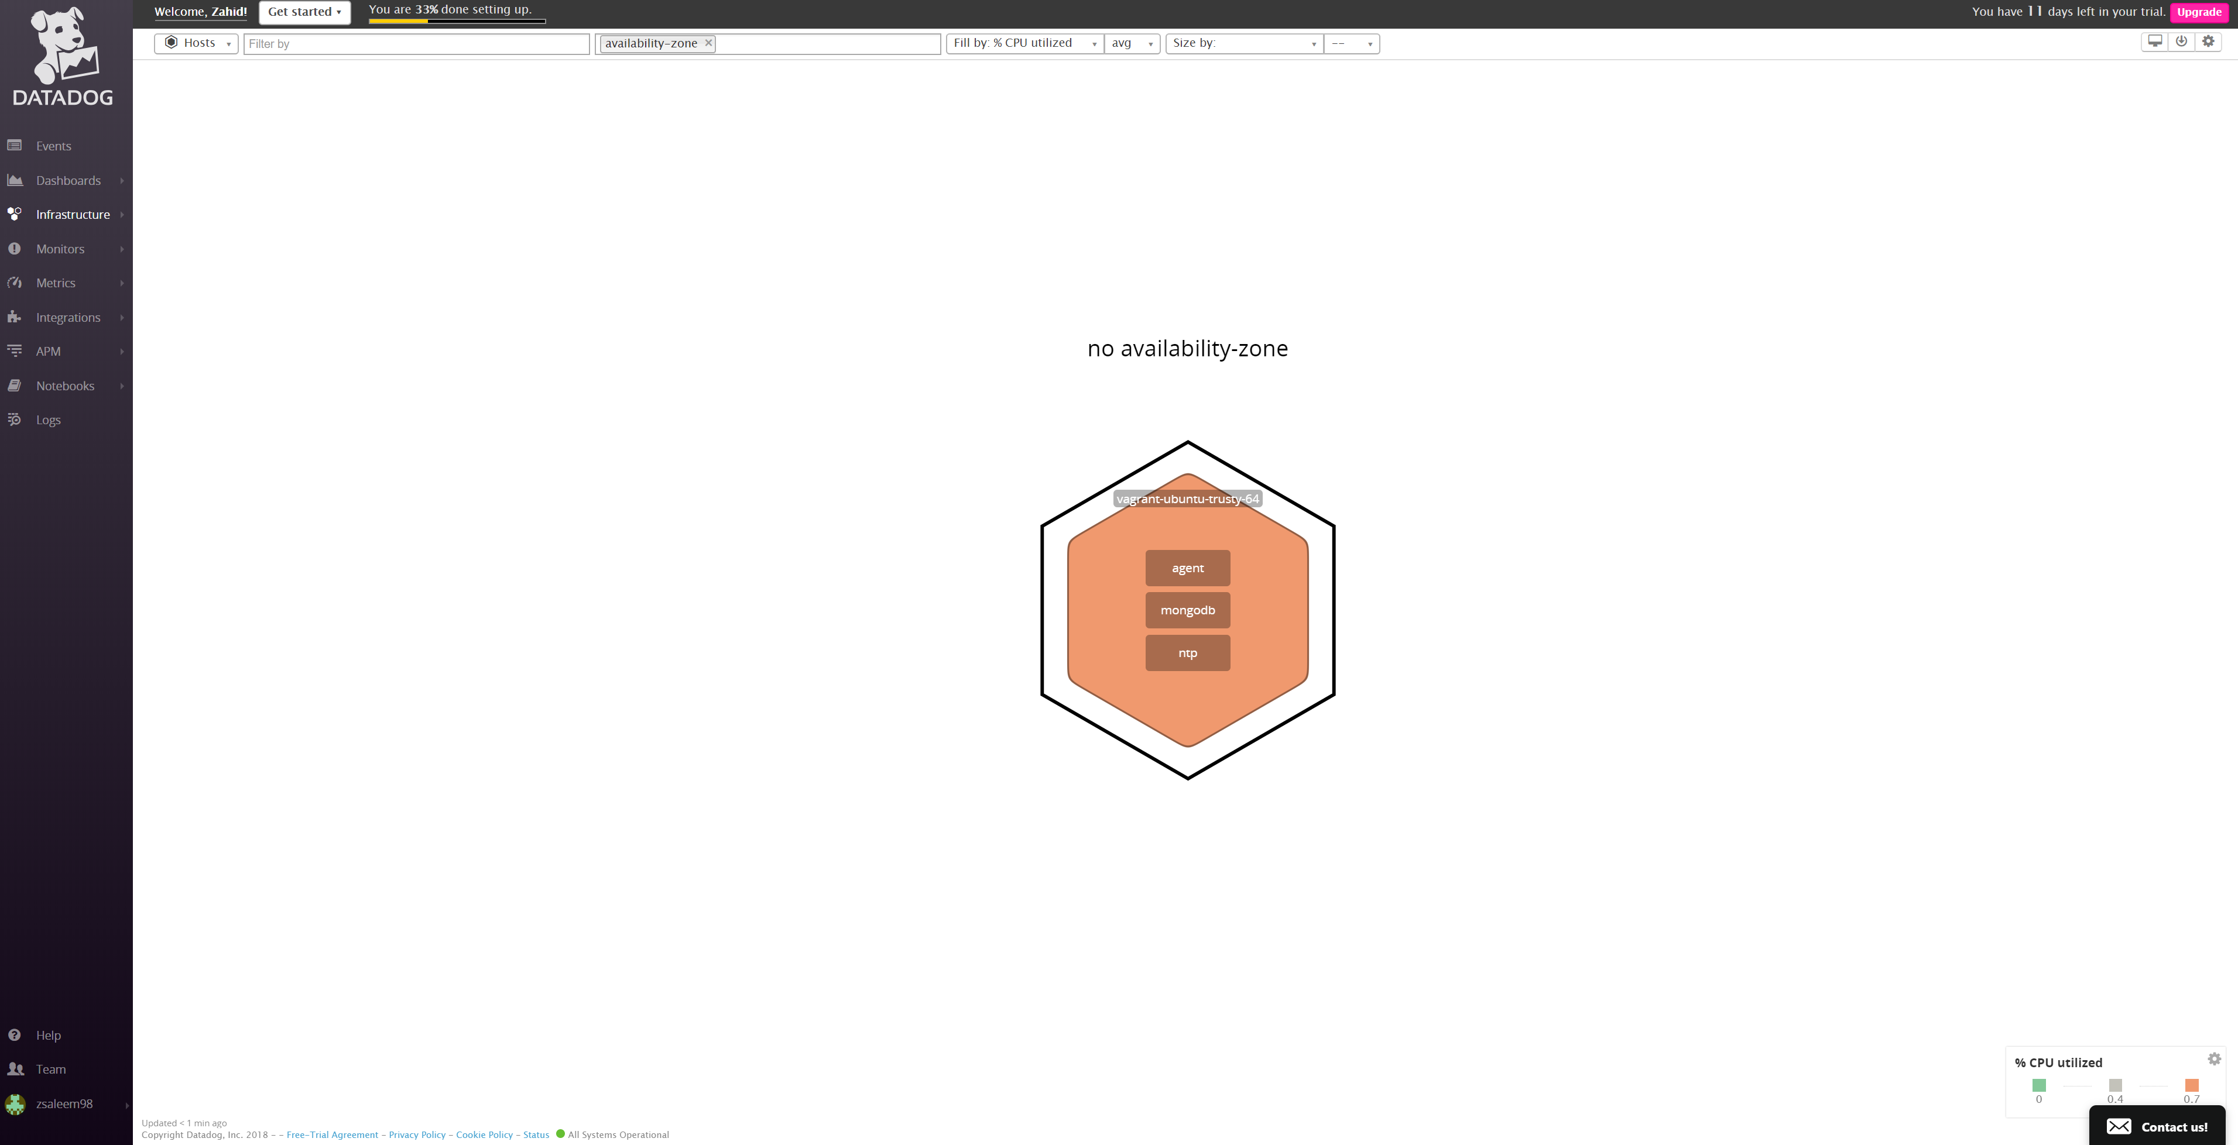

Monitoring Data – Infrastructure System Overview

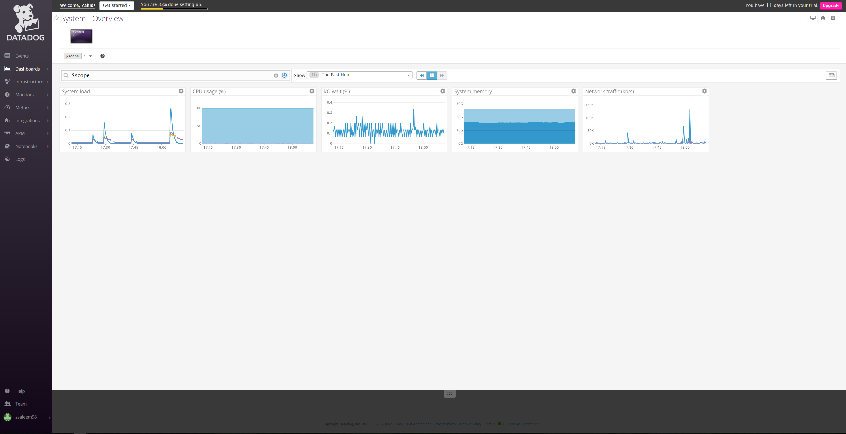

Visualizing Data – Metrics scoped

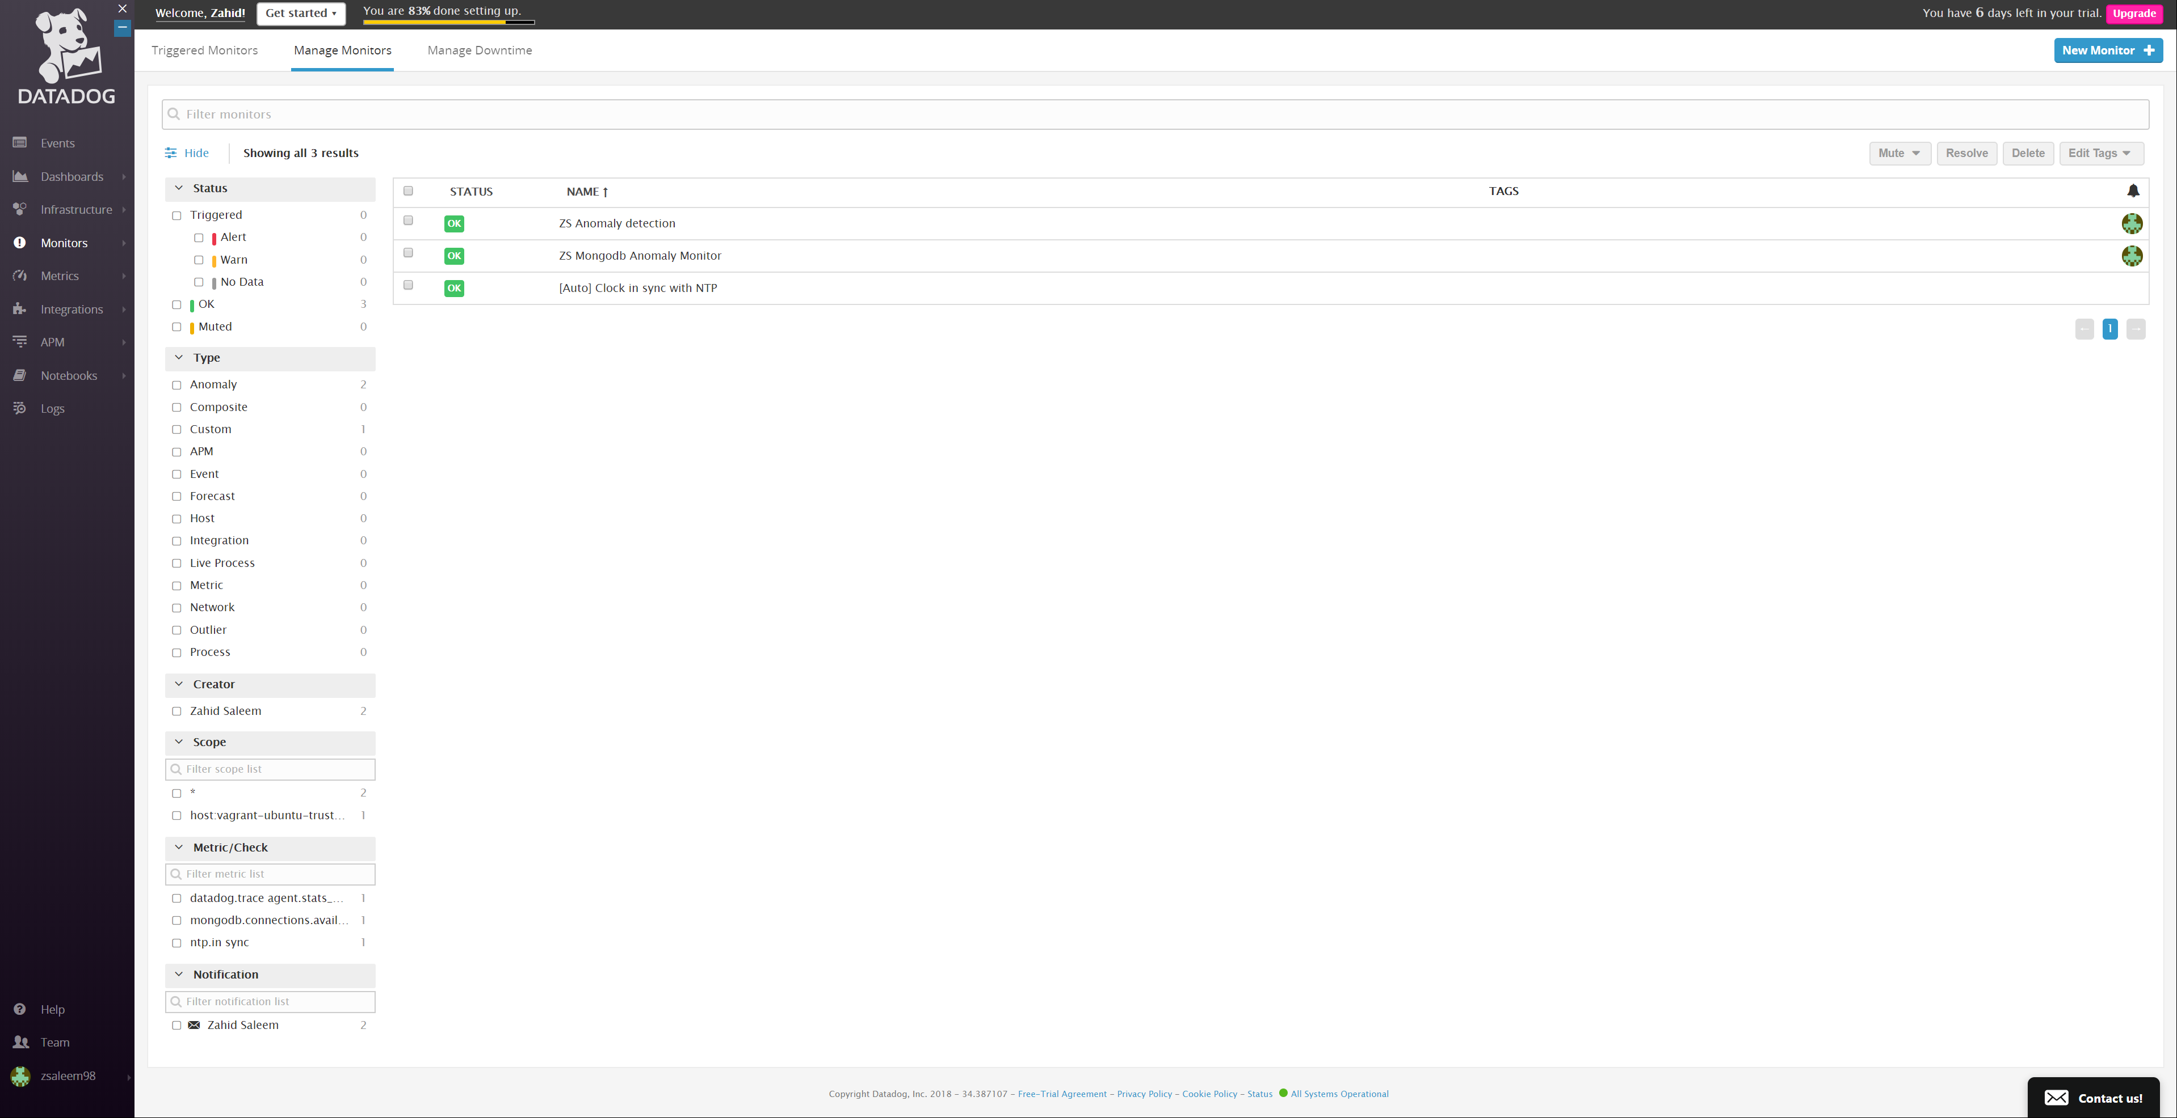

Monitoring Data - Dashboards

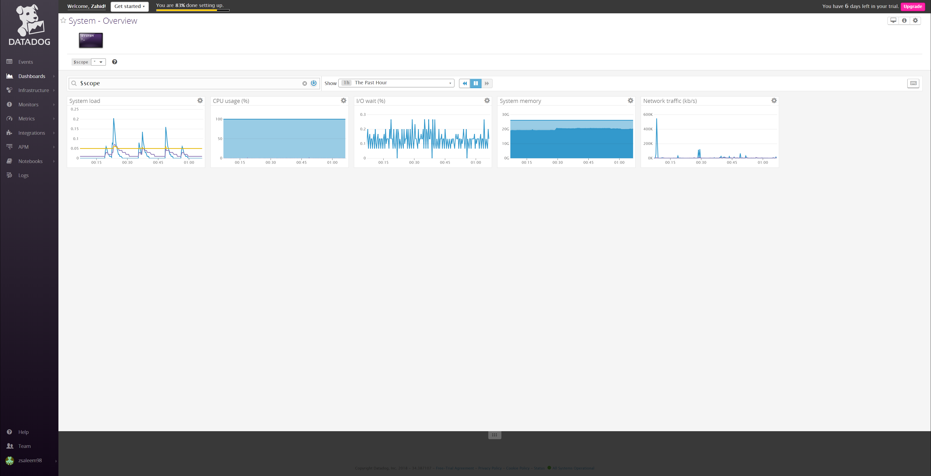

Monitoring Data – Metrics (ZS MongoDB Anomaly Monitor)

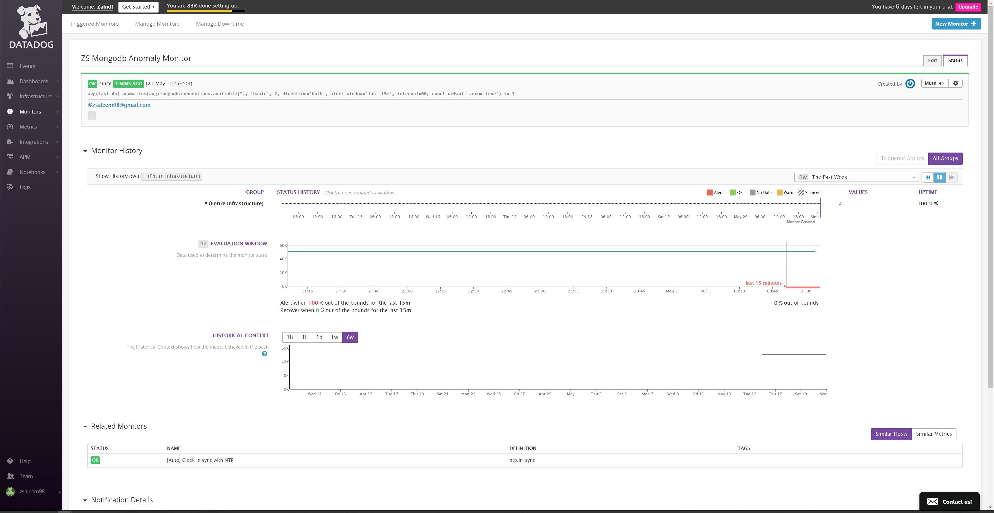

Past 5 mins

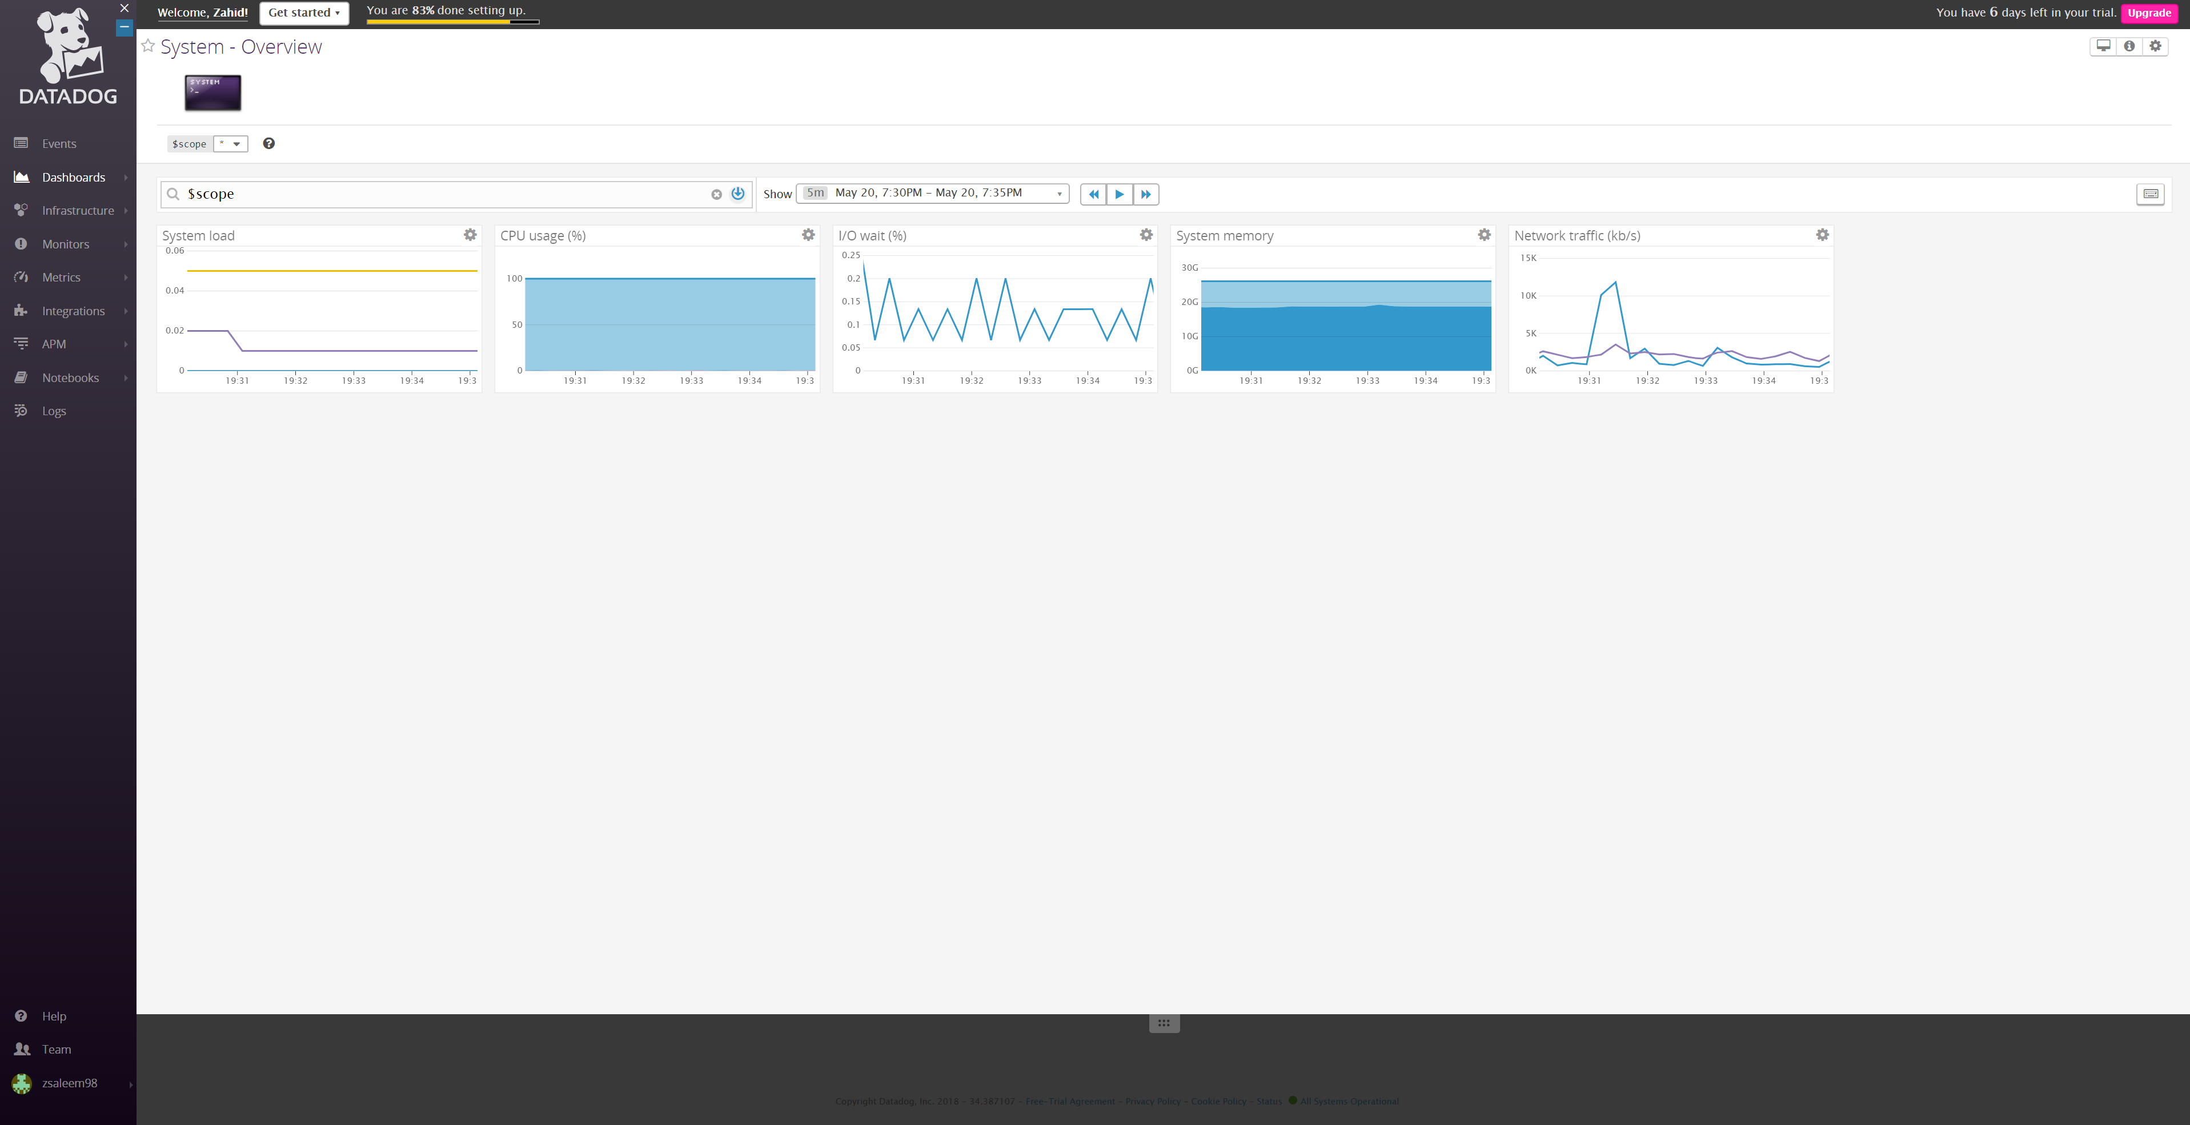

Notifications

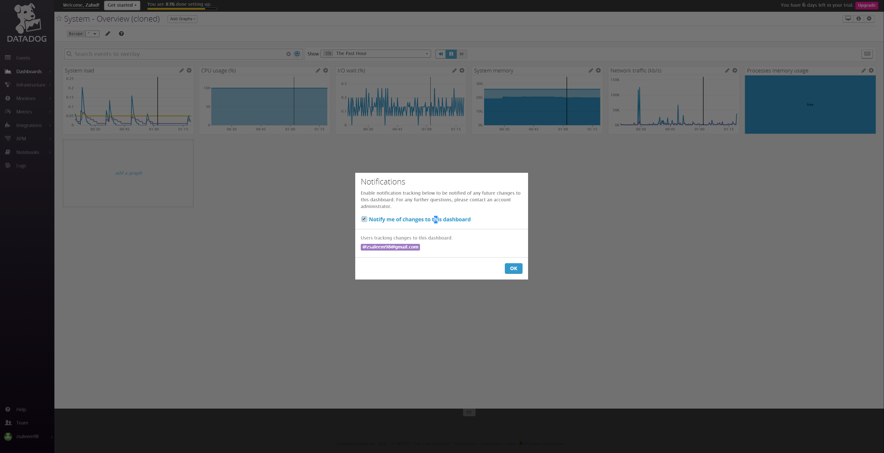

Monitoring Data - Metrics

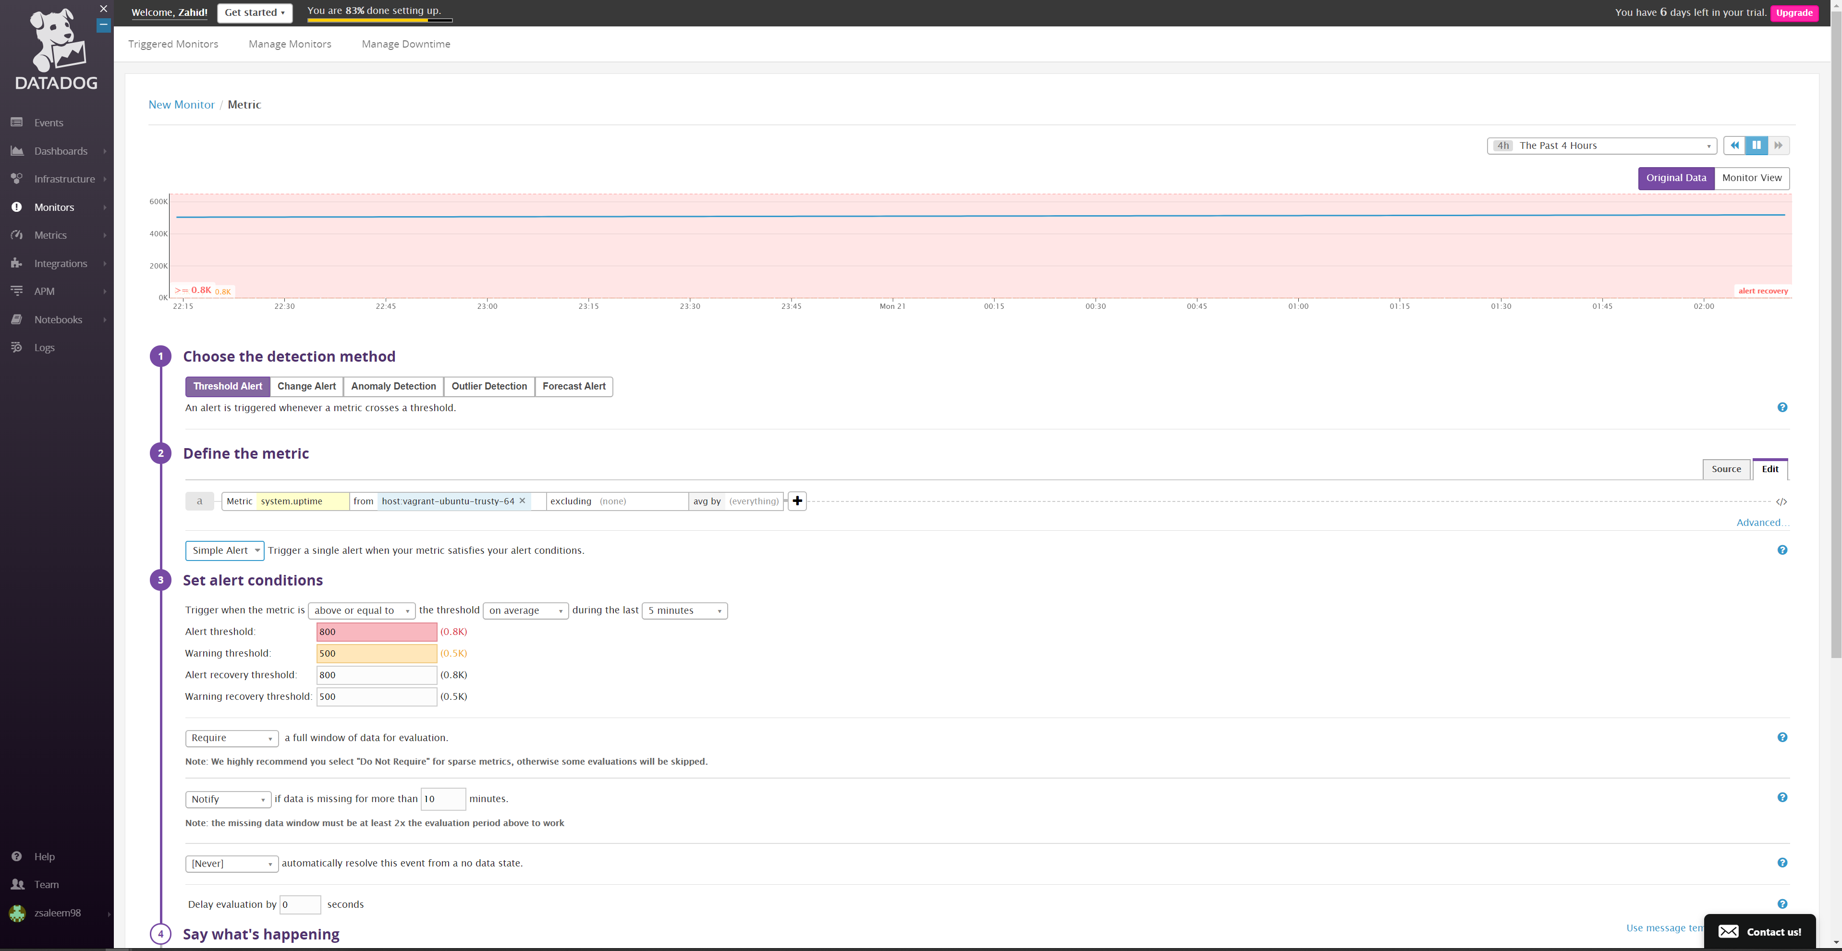

Monitoring Data - Metrics

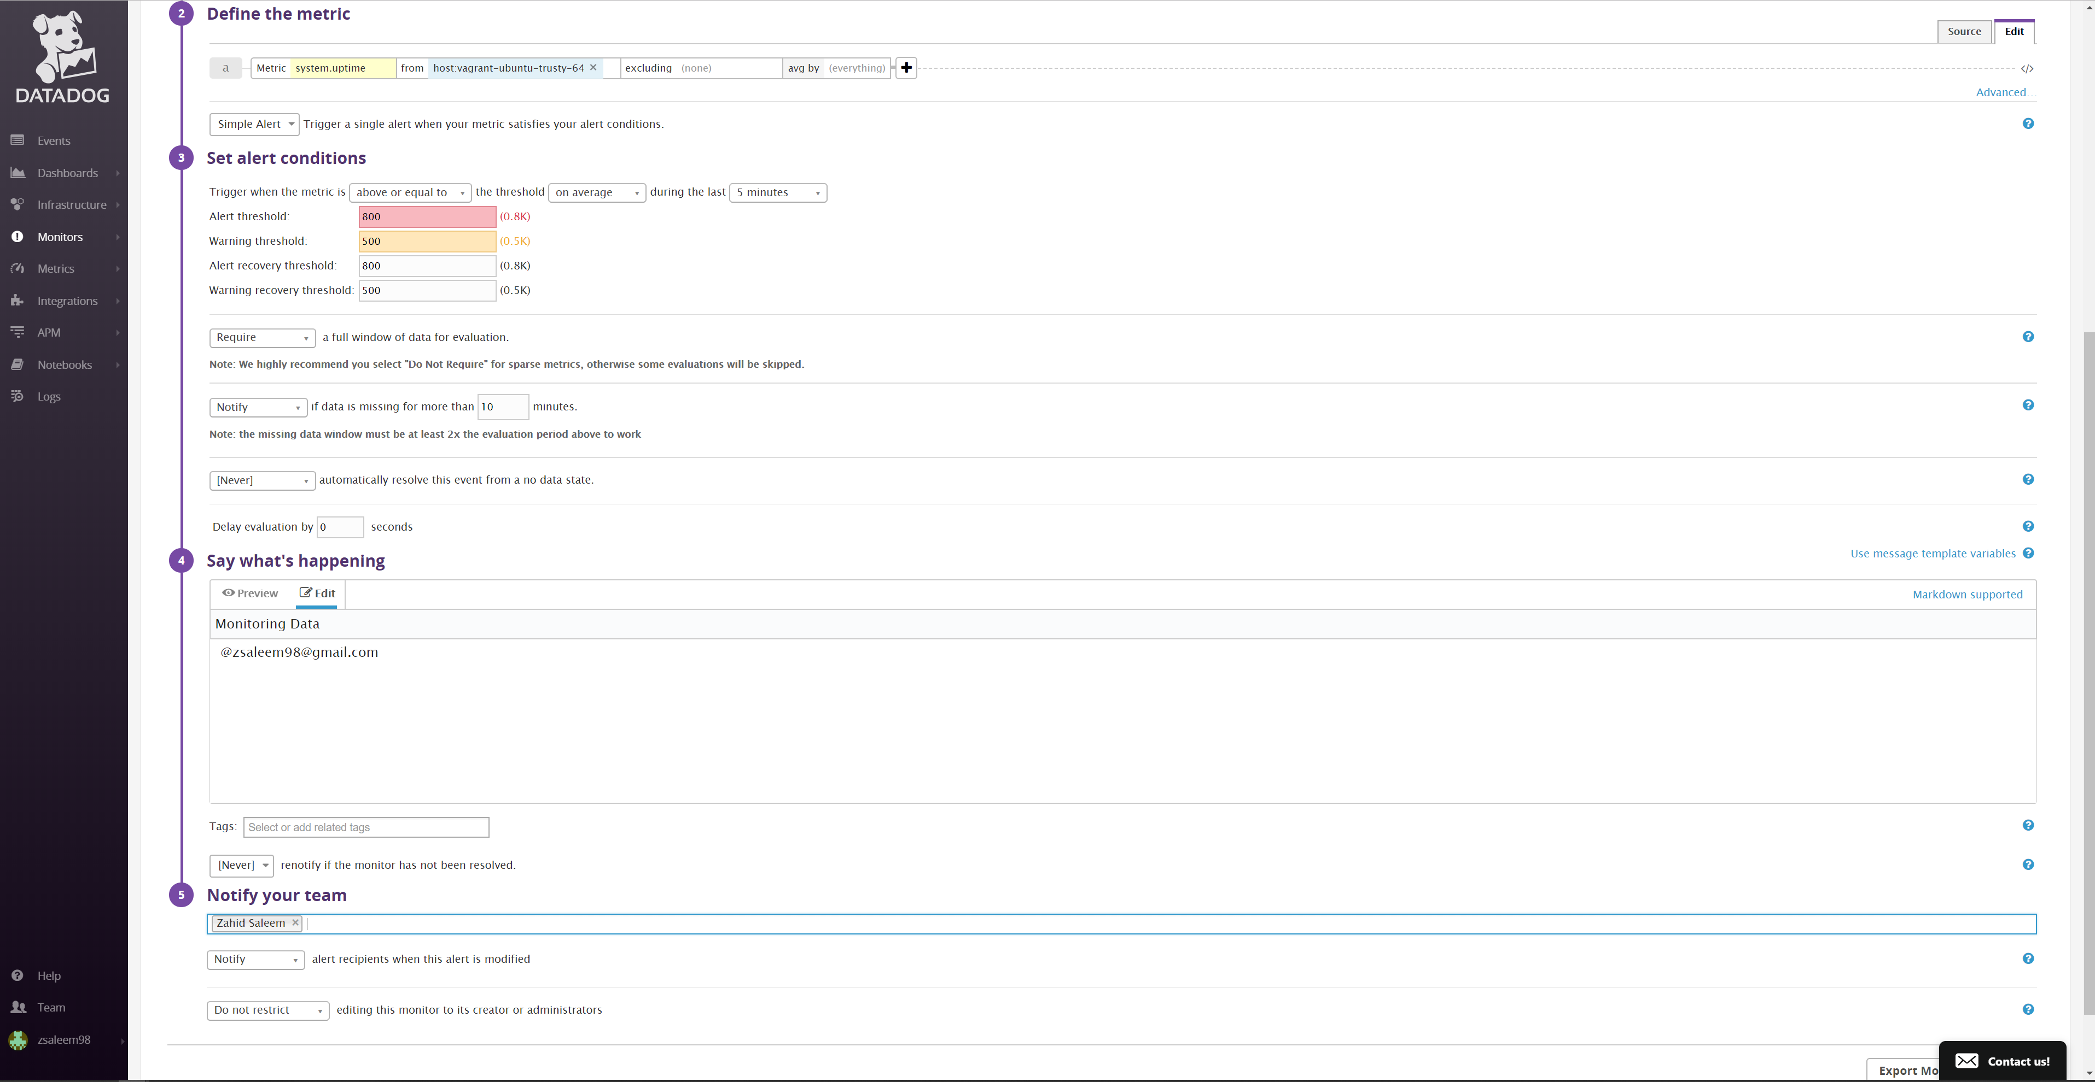

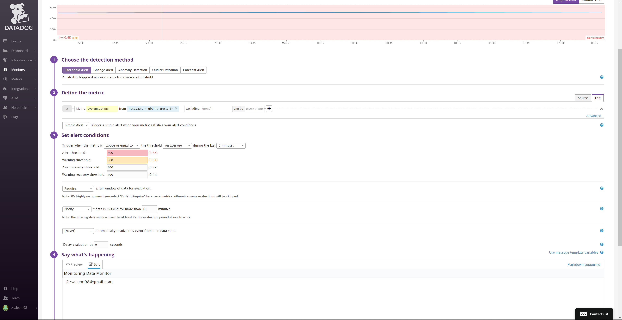

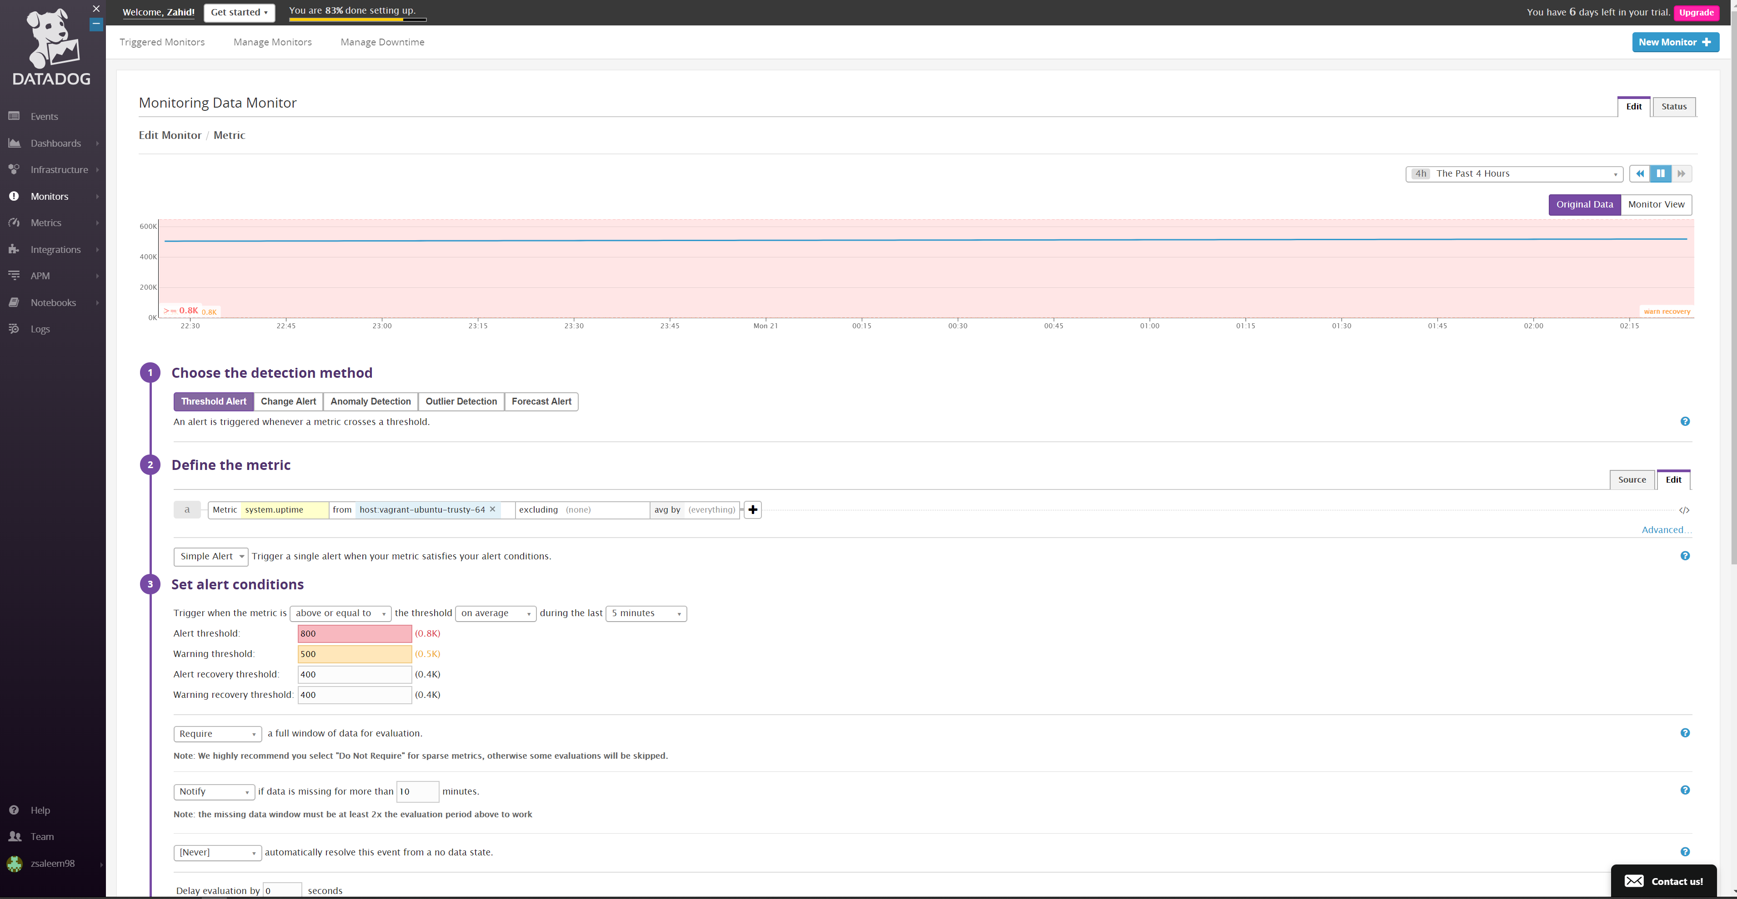

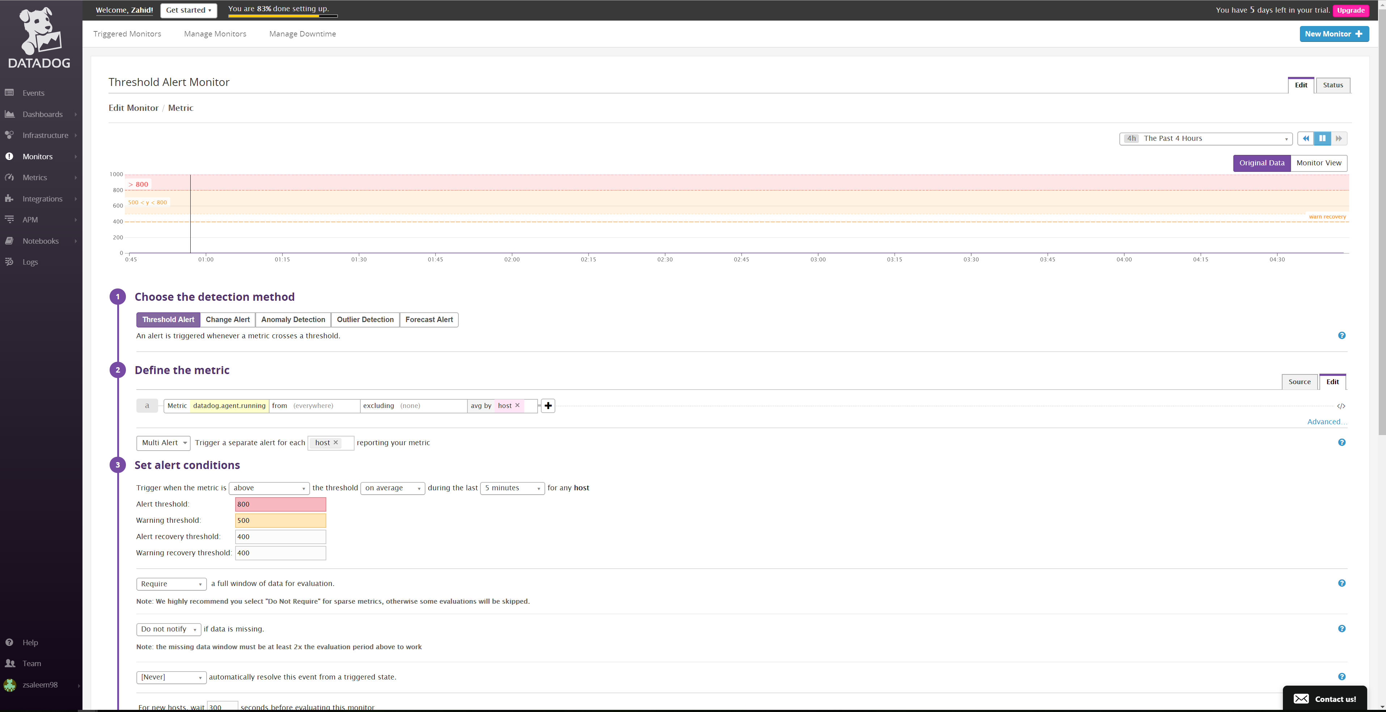

Monitoring Data – email notification

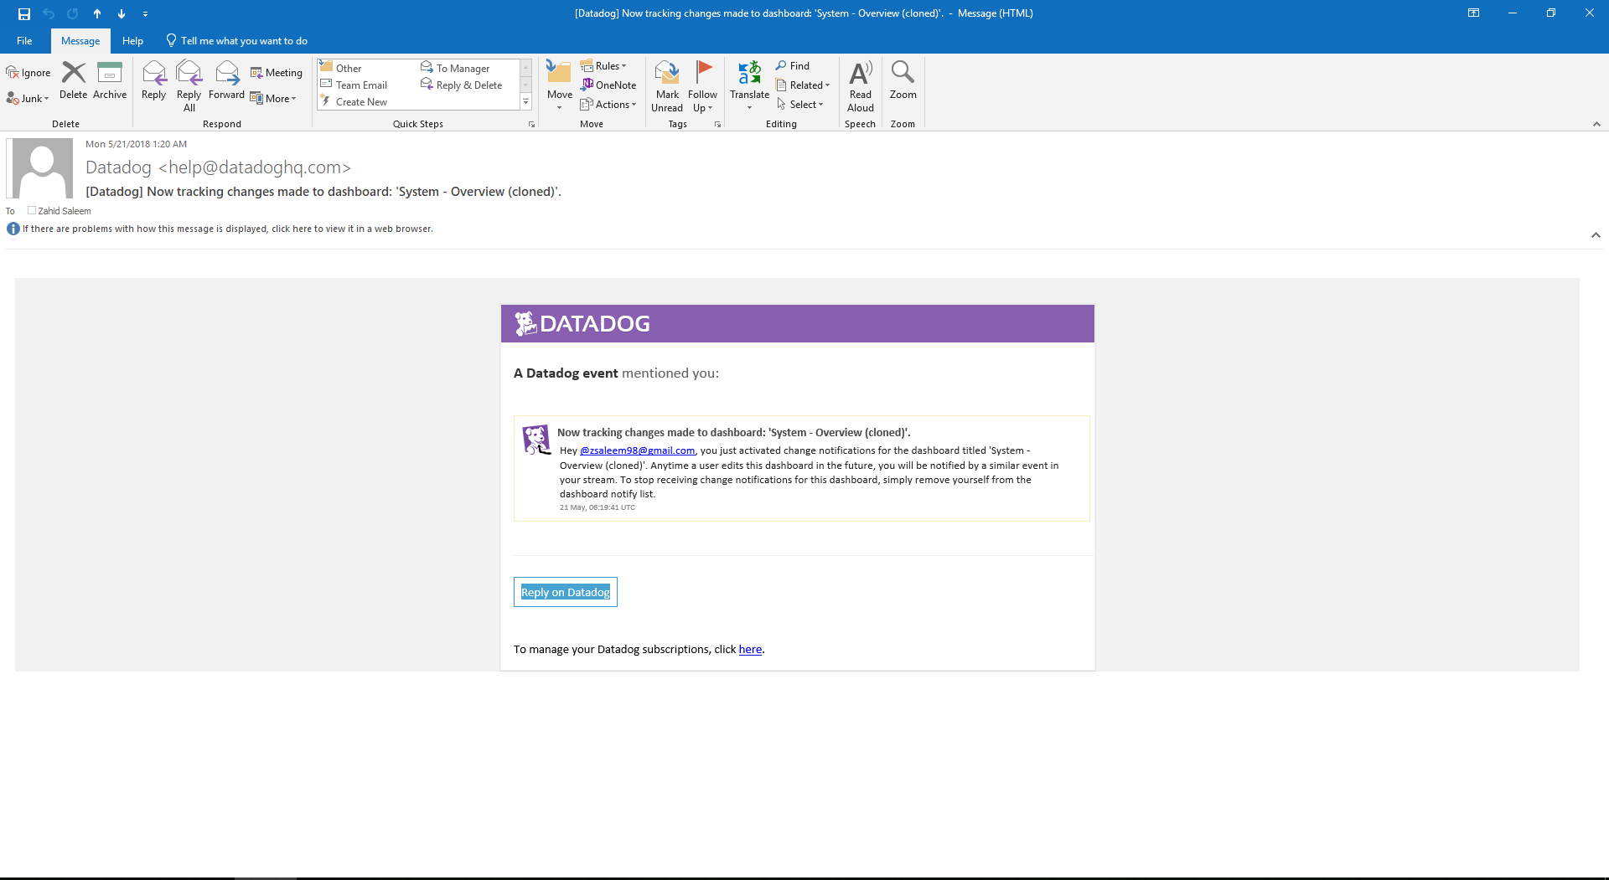

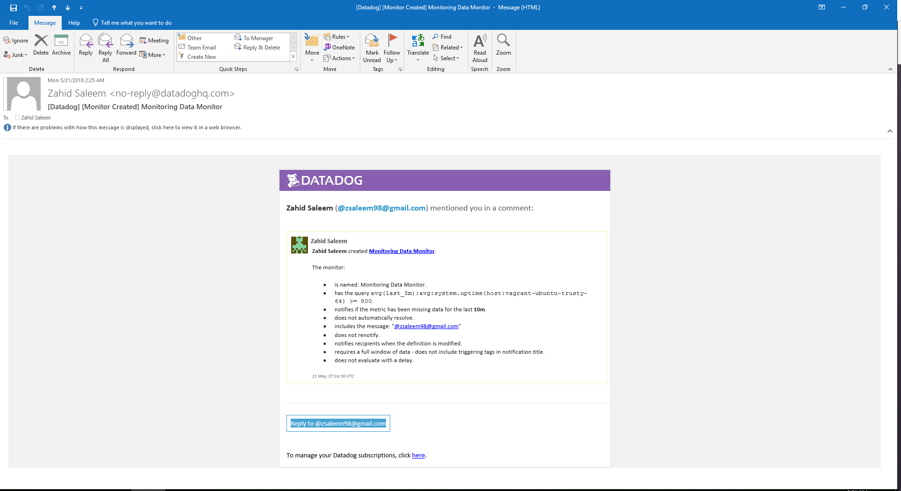

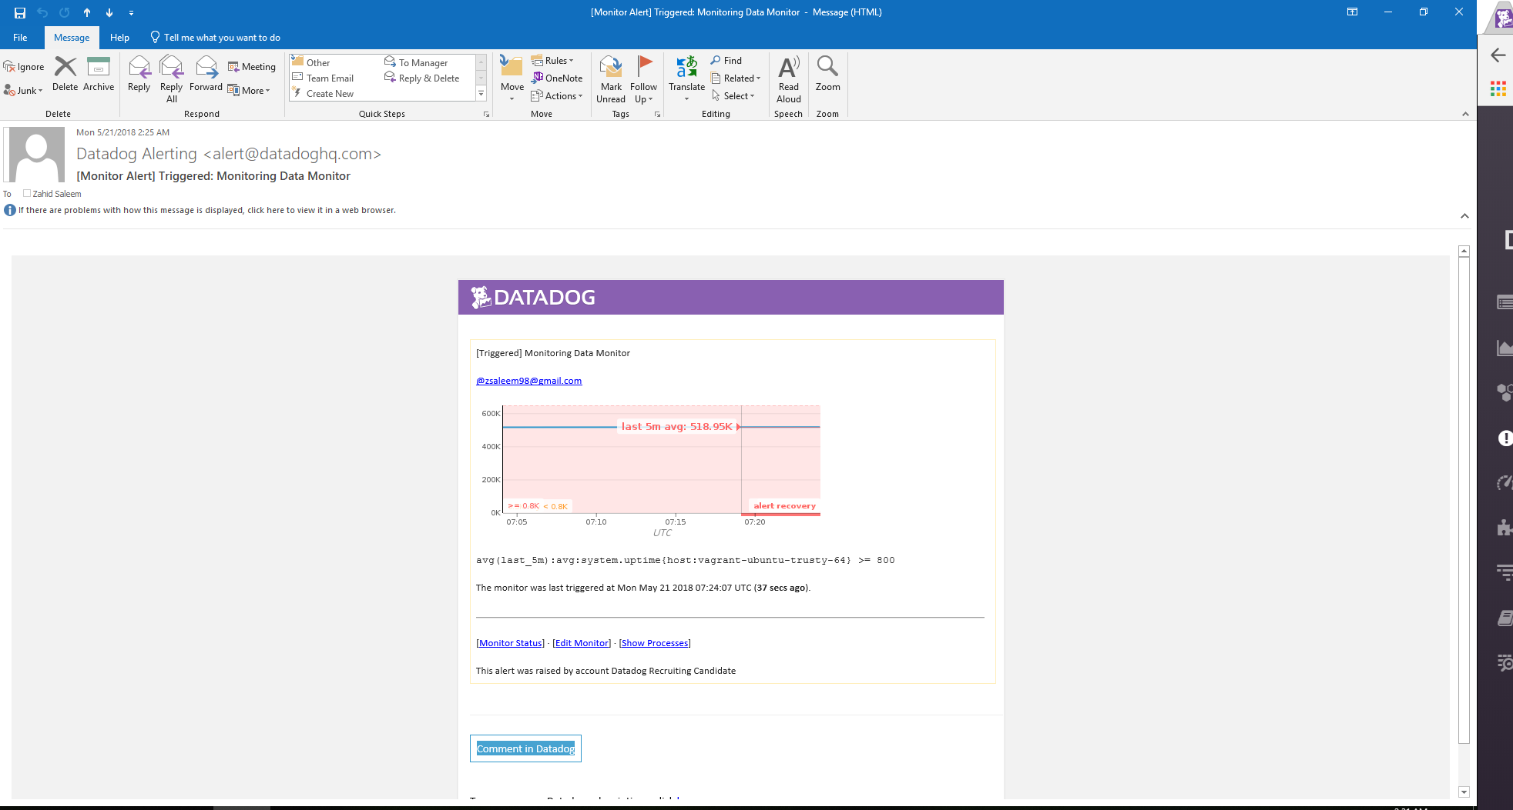

Collecting APM Data: myapp.py file

